DP History of the Americas - year 2

Human history becomes more and more a race between education and catastrophe.
H.G. Wells

Here we are, your final year of high school and the culminating round of the IB experience. The day-to-day mechanics will work much the same as last year, with an increased focus on international figures and events. From nuclear silos in the Urals to the steamy jungles of Latin America and central Africa, year two promises to deliver a great deal of content that will be new to most of you.

Classroom rules and procedures
- Be in class on time
- ipads, laptops, and cell phones are encouraged but are to be used with teacher’s approval. Devices taken up during class can be sent to the school office
- Be respectful of your classmates, teacher, and the learning environment
- Assignments, notes, supplemental material, study guides, and notices will be updated regularly on managebac.
- Please see Mr. McGann when you are absent or if you are having any problems. My email is mcgann_alexander@hcde.org
Grade Breakdown
Tests / projects %50
Quiz / classwork %30
Homework %20

External Assessments 20%
Paper One (The Move to Global War)
60 minutes
four short-answer / structured questions
25 marks
Paper Two (Causes and Practices of War / Cold War) 25%
90 minutes
two extended response questions
40 marks
Paper Three (Civil War / Civil Rights / WWII in Americas) 35%
150 minutes
three extended response questions
60 marks
Internal Assessment 20%
25 marks

Year One Year Two
Civil War The Move to Global War
Civil Rights Causes and practices of war
World War II and WWII in the Americas The Cold War

A) First Nine Weeks
Prescribed Subject - The Move to Global War
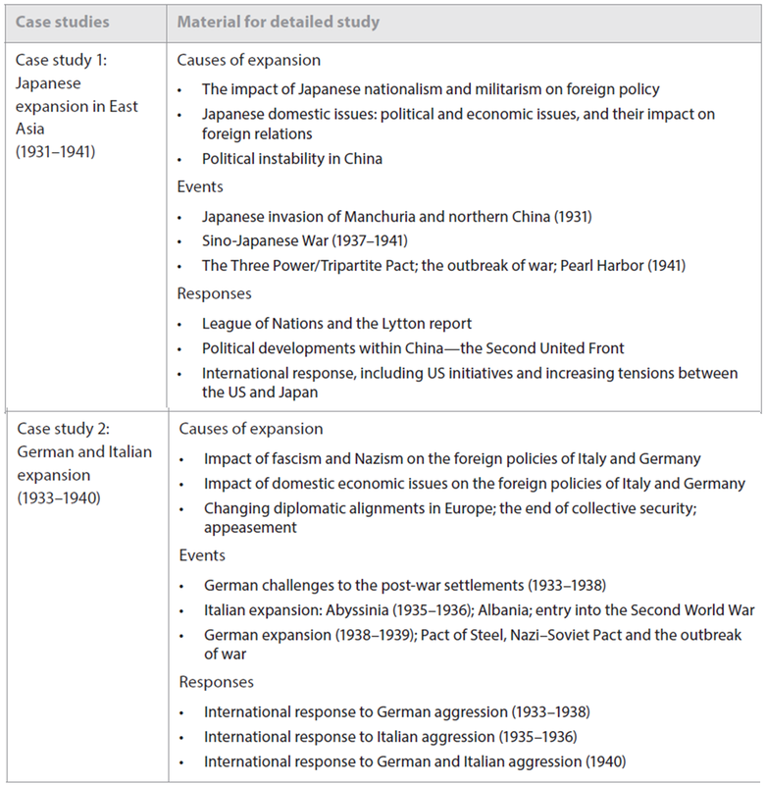

B) Second and Third Nine Weeks
World History Topic 1

Causes, practices and effects of wars
--- Major Themes
Different types and nature of 20th
century warfare
- Civil
- Guerrilla
- Limited war, total war
Origins and causes of war
- long term, short term and immediate causes
- economic, ideological, political, religious causes
Nature of 20th century wars
- technological developments, tactics and strategies, air, land and sea
- home front: economic and social impact (including changes in the role and status of women)
- resistance and revolutionary movements
Effects and results of wars
- peace settlements and wars ending without treaties
- attempts at collective security pre- and post- Second World War
- political repercussions and territorial changes
- post-war economic problems

-- Material for detailed study
Second World War (1939-45)
Nigerian Civil War (1967-70)
Nicaraguan Revolution (1976-79)
Spanish Civil War (1936-39)
Gulf War (1991)

C. Fourth Nine Weeks
World History topic 5
The Cold War

--major themes
Origins of the Cold War
- ideological differences
- mutual suspicion and fear
- from wartime allies to post-war enemies

Nature of the Cold War
- ideological opposition
- super powers and spheres of influence
- alliances and diplomacy in the Cold war
Development and impact of the Cold War
- global spread of the Cold War from its European origins
- Cold War policies of containment, brinkmanship, peaceful coexistence, detente
- role of the UN and the Non-Aligned Movement
- role and significance of leaders
- arms race, proliferation and limitation
- social, cultural and economic impact
End of the Cold War
- break-up of Soviet Union: internal problems and external pressures
- breakdown of Soviet control over Central and Eastern Europe

-- Material for detailed study
- Wartime conferences: Yalta and Potsdam
- US policies and developments in Europe : Truman Doctrine, Marshall Plan, NATO
- Soviet policies, Sovietization of Eastern and Central Europe, COMECON, Warsaw Pact
- Sino-Soviet relations
- US-Chinese relations
- Germany / Berlin 1945-61), Congo (1960-64), Afghanistan (1979-88), Korea, Cuba, Vietnam, Middle East
- Castro, Gorbachev, Kennedy, Mao, Reagan, Stalin, Truman

