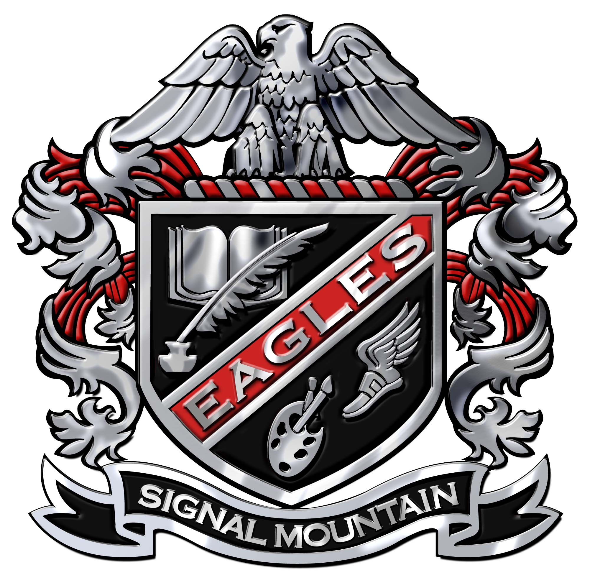
Assessment Policy
Signal Mountain Middle/High School
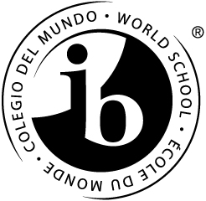

Purpose of Assessment
- To inform students of their progress and achievement
- To identify areas of growth for students
- To provide feedback for learning
- To shape instructional practices through the use of data
- To determine needs for differentiation of instruction
- To monitor student progress
- To inform parents of student progress against standards
Principles of Assessment
- Assessments are varied in type and purpose
- Definitions
- Summative assessment: Evaluation of student achievement through a culminating activity generally at the end of a course of study.
- Formative assessment: Evaluation aimed at identifying the learning needs of students and forming part of the learning process itself. Formative assessments take place throughout a course of study.
- Students should be allowed multiple opportunities to demonstrate their understanding.
- Summative assessments align with the criteria as outlined in subject guides.
- Clear criteria are given to students prior to an assessment.
- Opportunities for reflection are provided.
- Assessments are differentiated and modifications are made when necessary to meet the needs of all students.
- Assessments are aligned with learner outcomes that create high expectations for all students.
- Assessment practices will be reviewed annually to promote continuous program development and improvement.
Assessment and Curriculum
- Assessments drive the curriculum and are aligned with the written and taught curriculum.
- Curriculum and assessments are aligned vertically, building on prior knowledge and skills.
- Assessments are designed to align with course outcomes, state standards, and MYP objectives and criteria.
- Global contexts will provide the context for unit design and will influence unit assessments.
- Teachers will write curriculum and assessments collaboratively and design assessments using the MYP/DP unit planner in ManageBac.
- Curriculum and assessments should reflect the intercultural aspects of the MYP and DP.
- Teachers teaching the same course will use common assessments.
Assessment Practices
- Assessment and evaluation practices and expectations are discussed with students at the beginning of each unit- including the distribution and discussion of rubrics.
- Rubrics are clarified using student-friendly language at the beginning levels.
- Exemplars are made available to students.
- Assessments allow students to reach the highest level of achievement in the rubric descriptor bands.
- MYP Assessments
- MYP objectives and criteria will be used during all years of the program.
- Summative assessments will include the prescribed minimum tasks for each subject area and will each be assessed twice a year.
- The Personal Project will be assessed using MYP Personal Project criteria.
- Teacher will record criterion achievement level scores for the MYP assessment in ManageBac.
- Assessment strategies may include: observation, selected response, open-ended tasks, performance, process journals, portfolios
- Assessment tasks may include: compositions, creations of solutions or products in response to problems, essays, questionnaires, investigations, research, performance, presentations (oral, written, graphic)
- Feedback will be provided in a timely manner. There will be a continuous cycle of presenting a challenge, performance, feedback and improvement.
- Teachers teaching the same courses participate collaboratively in the planning, development, and standardization of assessments where appropriate.
- Authentic assessment tasks will provide opportunities for students to apply learned knowledge and skills to real-life situations.
- Assessments will be differentiated to address a variety of learning styles and modifications will be made for students with identified learning disabilities.
- Assessments will be learner centered, inquiry-based, and authentic in nature.
Reporting to Parents
- Evidence of learning will be shared with parents through conferences and progress reports every three weeks and report cards.
- MYP assessment criteria scores will be reported alongside traditional grades.
- MYP report card reports will display a numerical grade of 1 – 8 for each subject area at the end of each semester.
- Parents have access to student progress through PowerSchool and, by Spring 2016, through ManageBac.
Assessment and Student Expectations
- Students are responsible for their learning.
- Students are required to submit both formative and summative tasks in a timely manner.
- Students are expected to know and use assessment criteria while completing work.
- Students are to synthesize and apply their learning, ask questions, and solve problems.
- Students should strive to produce quality products and performances and to use assessment as a way to improve their learning.
- Students should regularly practice self-assessment, peer assessment and complete reflections on their learning.

