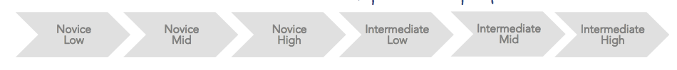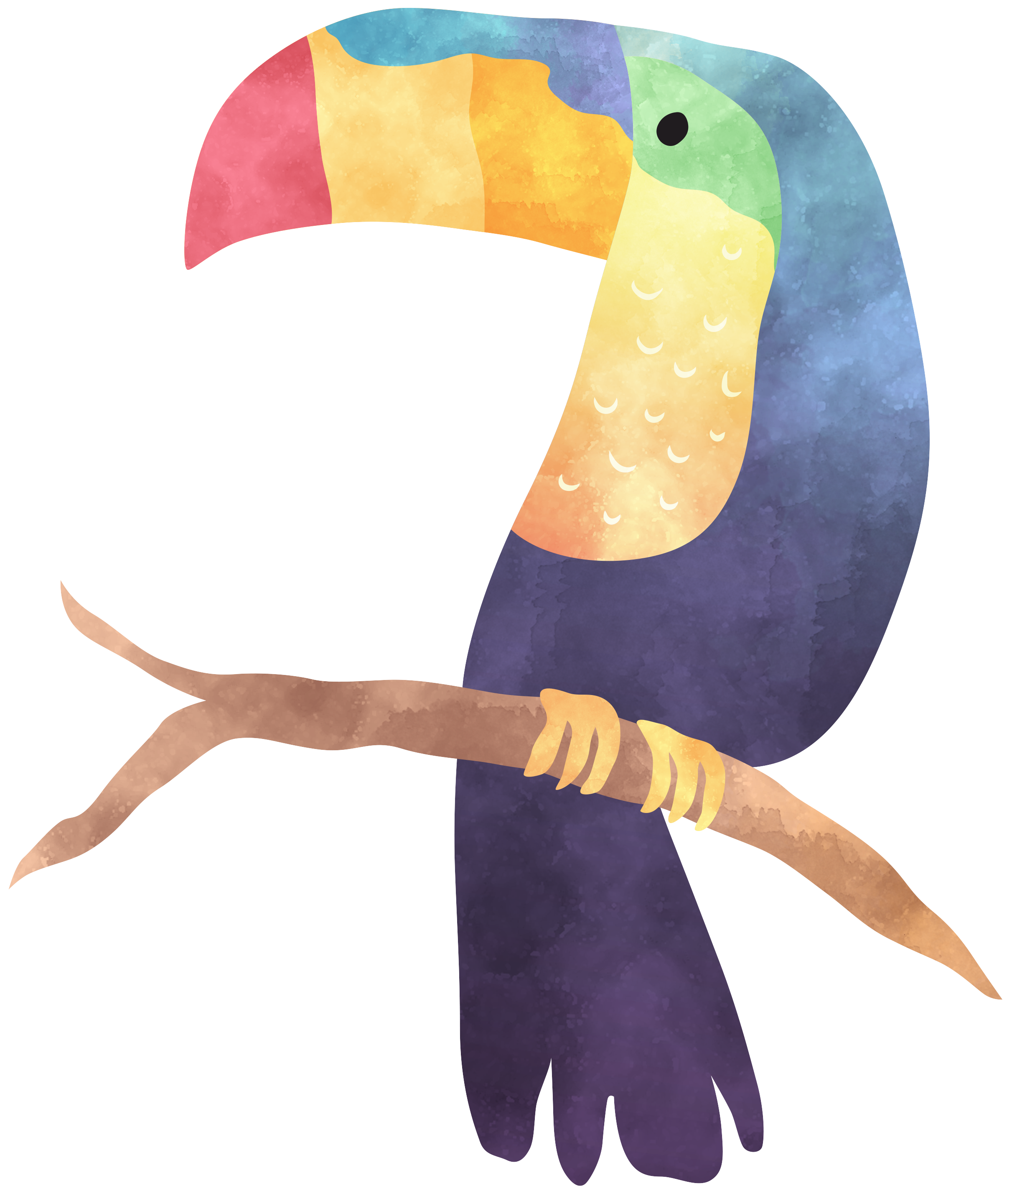

* Class will be conducted in Spanish at least 50% of the time. In order to learn to communicate in Spanish, you must listen, read, write and speak in Spanish as much as possible.
* We will do our own work. This means we will not use online translators. Use [wordreference.com](http://wordreference.com).
* The goal is to move forward in our proficiency, so if you are absent, it is your responsibility to check the absent folder, Google classroom, ask a friend, and then Sra. Duke what you missed, and make it up as soon as possible.
* We will have a supportive and positive learning environment where everyone helps each other to learn and grow.

**WHAT WILL I DO TO GET THERE?**

**ESPAñol 2 learning targets**

* INTERPRETIVE LISTENING - I can understand familiar words,

phrases & sentences that I hear, including some details in Spanish.

* INTERPRETIVE READING- I can understand familiar words,

phrases & sentences that I read, including some details in Spanish.

* INTERPERSONAL SPEAKING - I can ask & answer simple

questions using phrases, simple sentences, and memorized language on familiar topics.

* PRESENTATIONAL WRITING - I can present basic information in writing about familiar topics related to everyday life using phrases, simple sentences, and language I have practiced.

# **What do I need to be successful for class?**

* 3 Ring Binder with tab dividers & loose paper, pen/pencil
* Colored pencils
* 3X5 index cards
* Your device. We will use phones and headphones in class when appropriate.
* A positive attitude - EVERYONE can learn a language

Let’s have an amazing year learning to communicate in Spanish. If you ever need anything, just ask!

**Plans for the semester:**

August- review Spanish 1 concepts

September- familia, tener, possessive adjectives, ser and estar

October- household objects, stem- changing verbs, daily routines

November- clothing, shopping, Day of the Dead, commands

December- around town, Navidad, past tense, pronouns

GOAL

español 2- Señora DUKE

**What will we do in Spanish class?**

This year we will be focusing on conversational Spanish. We will converse in Spanish with our classmates, Senora Duke, and Skype with people from around the world. You CANNOT learn Spanish if you do not practice!

email [Duke_jen@hcde.org](mailto:Duke_jen@hcde.org) ext. 214

///78888888888888888888888888888888888888888888888888888888888888888888888888888888888888888888888888888888888888888888888888888888888888888888888888888888888888888888888884

8