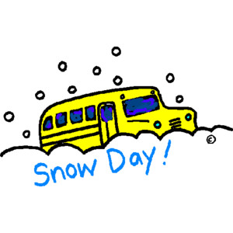
Early Dismissal Procedure
In the event of an early dismissal due to snow or inclement weather of any type, please complete this snow procedure letter. This copy will stay with your child’s teacher in the classroom and he or she will follow your request completely. Please familiarize your child with your procedure request so they he or she will know what to do in the likely event that school is dismissed early due to bad weather.
Please select only ONE option.
Child’s Name:_______________________________ Teacher’s Name:_____________________
____ My child is to ride bus #____ home.
____ My child is to ride bus #____ to ___________________________ house. The address is _______________________________________________________________________.
____ My child is to be picked up by __________________________________________.
____ I will pick my child up at school by the designated closing time.

Please refer to the handbook for further inclement weather information and procedures. These days are always stressful for faculty and students. Please always monitor the recommended resources to ensure a smooth day for your child. THANK YOU!!

