
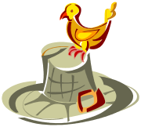

Thursday, November 10th, 2016

Lisa Marie Boyatt
lboyatt@oneidaschools.org
569-8340

A Cornucopia of Learning
Reading
Letter sounds: h t n l i
Sight words: as have
Independently read: Nan and Lad

Writing: Personal Narrative
Students will move from labeling their pictures with words to making a 3 page book with sentences. They will practice story order by using the words first, next, and last.

Science/Social Studies:
Students will study plant and animal life cycles. They will also be able to determine the difference between living and non-living things. Students will also compare plants and animals to find similarities and differences. (ex. They both grow and need water).

Math: Comparing
- Identify if objects in one group is more, less, greater than, fewer, and/or equal by using matching and counting strategies.
-Identify “first” and “last” related to order or position.
-Compare two numbers between 1 and 10 presented as written numerals.
-Compare length, weight, and capacity of given objects

A Feast of Upcoming Events

Nov. 11th – NO SCHOOL – Veteran’s Day
Nov. 23rd – 25th – NO SCHOOL –
Thanksgiving Break

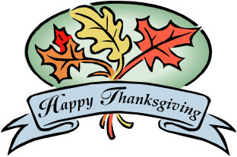

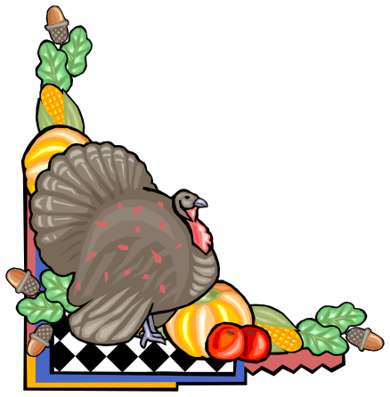
Check out my website:
1. Go to www.oneidaschools.org
2. At the top click on schools.
3. Select Oneida Elementary School
4. Click on School Staff on the left side
5. Click on my name Lisa Boyatt
*I will keep it updated with homework, Newsletters, Skills, etc.

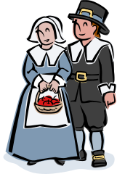

Sight Words
a am and as at go had have he
has I in of see the to you we

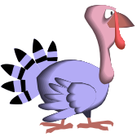

Sound-Out Words of the Week

Nan Lad nap lap land laps naps damp

