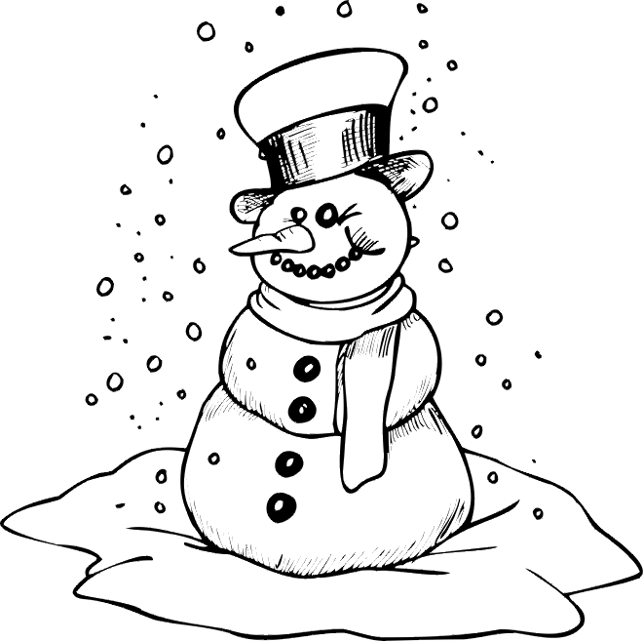 Unit: My Shadow
Homework Tasks
Jan. 9th | Read “Ron Hops”  Say the months of the year in order.
Jan. 10th | We have just begun a new unit called My Shadow. We will be studying many different concepts about shadows, such as how shadows are made and where we can find shadows. Write a question on the sticky note that you have about shadows. Pick one of these question words to start your sentence: Why? How? Where? When? What? We will post it on our concept/question board. Write your name on the sticky note.  Draw a picture and write a sentence telling about something you did over Winter Break.  at the bottom of this page
Jan 11th | Draw a picture and write a sentence telling about something you did to celebrate Christmas. (on back)
Jan 12th | Write the beginning sound for each picture. (on back)
Winter Break

////////////////////////////////////////

//////////////////////////////////////////
