Pleasanton Elementary Third Grade Math Log
February 25 - March 1, 2013

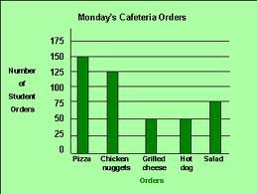
Monday, February 25
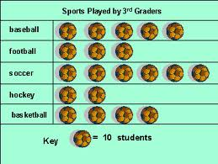
- Fill in the table to match the graph
Sports | Sports Played by 3rd Graders
Baseball
Football
Soccer
Hockey
Basketball

- How many more students played soccer than football?
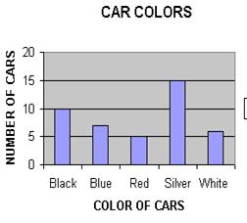
- Label the graph.
- How many more people drive cars that are blue than white? _____
- How many more people drive cars that are silver than black? ______
Tuesday, February 26
- How many students ate meals that were NOT salads?

- How many more students ate pizza and grilled cheese than chicken nuggets?

- The graph below shows the number of pizzas eaten at a food competition. Which pictograph best represents the tally chart?

900 456 325
-189 - 68 -158

Wednesday, February 26
- Students were asked choose their favorite color. The results are displayed in the pictograph below. Which bar graph displays the same data?
- How many students voted in the above survey?

The tally chart shows the coins that Ben has in his coin collection.

- How many more dimes and nickels does Ben have than quarters?

156 34 45
+89 x 5 x 6
Thursday, February 27
1) Stephanie was collection soda bottles to recycle. The graph below represents what she has collected so far.
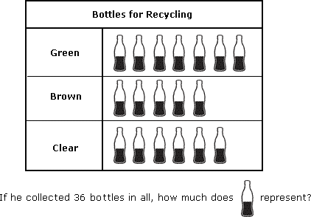

Students are gathering T-shirts to donate. The graph below shows how many T-shirts each student has collected.
2) How many T-shirts does represent?
3) How many more T-shirts have Kevin and Karin collected than Steve and William?

346 45 78
+79 x 5 x 6

