Rappahannock 4-H
Overnight Camp
June 12-16, 2022
Attention: CAMPERS, CIT and TEENS!
Campers- 9 to 13-year olds will LOVE spending a week at this action-packed camp! Campers arrive Sunday evening and spend the next four days participating in activities such as swimming, canoeing, performing in talent show and ending each day at the campfire circle. Campers sleep in dormitories on site.
Please contact Linda Baldwin @ lindab75@vt.edu if you would like to be added to the camper, cit or teen list!

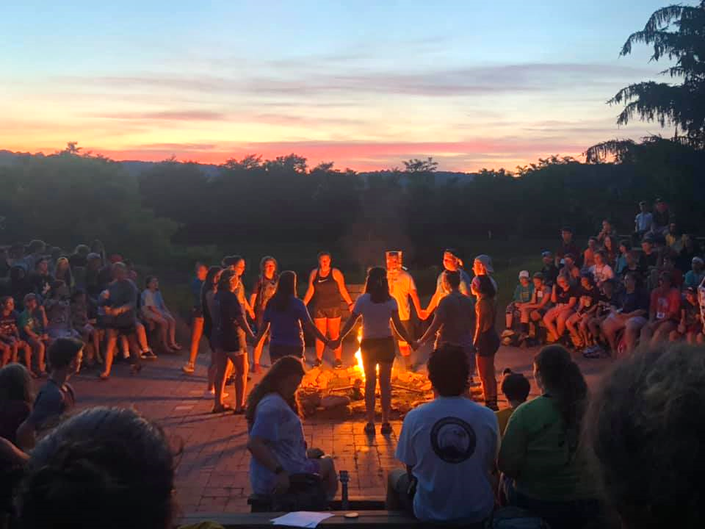

I

f you are a person with a disability and desire any assistive devices, services or other accommodations to participate in this activity, please contact Linda Baldwin, Rappahannock VCE at (540-675-3619)/TDD*) during business hours of 8 a.m. and 4:30 p.m. to discuss accommodations 5 days prior to the event.*TDD number is (800) 828-1120.

