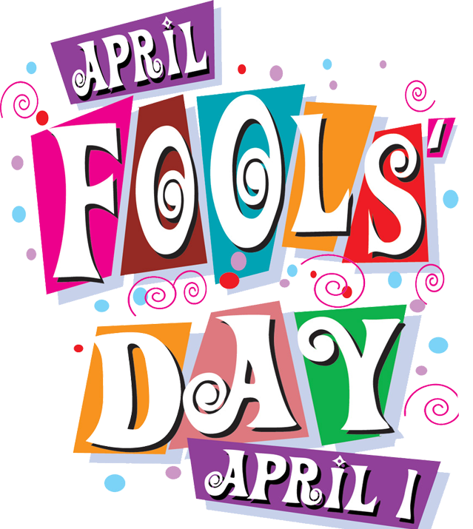
Class News
Mrs. Williams’ Second Grade
April 4, 2022

Reading Skills: sequencing, distinguish between real and make believe, make inferences, use see/saw, give/gave correctly

Language: suffixes

Spelling: R-control: ir, er, or, ur, ar

Math: fractions continued

Science/Social Studies: life cycles

