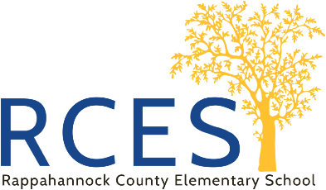
34 Schoolhouse Road
Washington, Virginia 22747
(540) 227-0200
Rappahannock County Elementary School

Principal-Lisa Gates Assistant Principal-Jennifer Wissinger

February 18, 2022

Dear RCES Families,
As always I want to thank you for your support in helping your child take care of their school I-pad or Chromebook this year. We are very fortunate to be able to issue each student in our school division their own electronic device. You may have noticed that students are starting to keep their devices at school. Teachers have a special cart in the classroom where individual devices can be charged and then distributed throughout the school day when needed. If a student is quarantined or needs to complete work on one of our online platforms, you may see your child bring their device home. If your child isn’t bringing their device home and you would like for them to, please notify your child’s homeroom teacher. If your child becomes quarantined and needs a device, we will make arrangements to ensure your child gets what they need. If you have any additional questions concerning school devices, please do not hesitate to reach out to me.

Kind Regards,

Lisa Gates-RCES Principal

