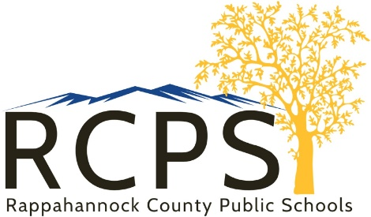

6 Schoolhouse Road
Washington, Virginia 22747
Telephone (540) 227-0023

Mental Health Update
February 15, 2022
Dear School Families,
This week our Middle School students attended an assembly entitled Helping Friends, which was presented by Alan Rasmussen, a suicide prevention manager with Rappahannock Rapidan Community Services. Students were informed of the importance of talking to a trusted adult when they notice a friend may be struggling with mental health issues including depression, feelings of hopelessness, and suicidal comments. Our RCES mental health team was available to debrief with students after the presentation. This team will follow-up with additional lessons to support our students social-emotional wellbeing and reinforce their presence as a support system for anyone feeling distress. A similar presentation is available for families by copying and pasting the following link:
https://www.youtube.com/watch?v=tOGHHlaAZv8
RCPS is committed to supporting the whole child as we continue to assess the impact of the COVID-19 pandemic. We have on-site counseling services available at no charge to families. Please feel free to contact Carol Johnson at 540-227-0259 or cjohnson@rappahannockschools.us if you are interested in these services.
Sincerely,
Carol Johnson
Carol Johnson, Ed.D.
Asst. Superintendent

