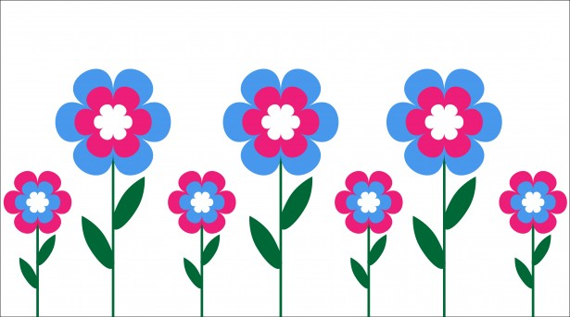
Mrs. Way’s Class News
Week of 4-19-22

Reading – Story: “Dinosaurs Travel”
Skill: Use a table of contents/words with ou, ough

Writing – Identify and write command and exclamation sentences

Math – Measurement (nearest inch and centimeter)

Science – Life Cycle of a Plant and Butterfly

Please study these words for a test on Fri., Apr. 22nd:

1. through
2. you
3. soup
4. group
5. youth
6. funny
7. these
8. walk
9. once
10. open

