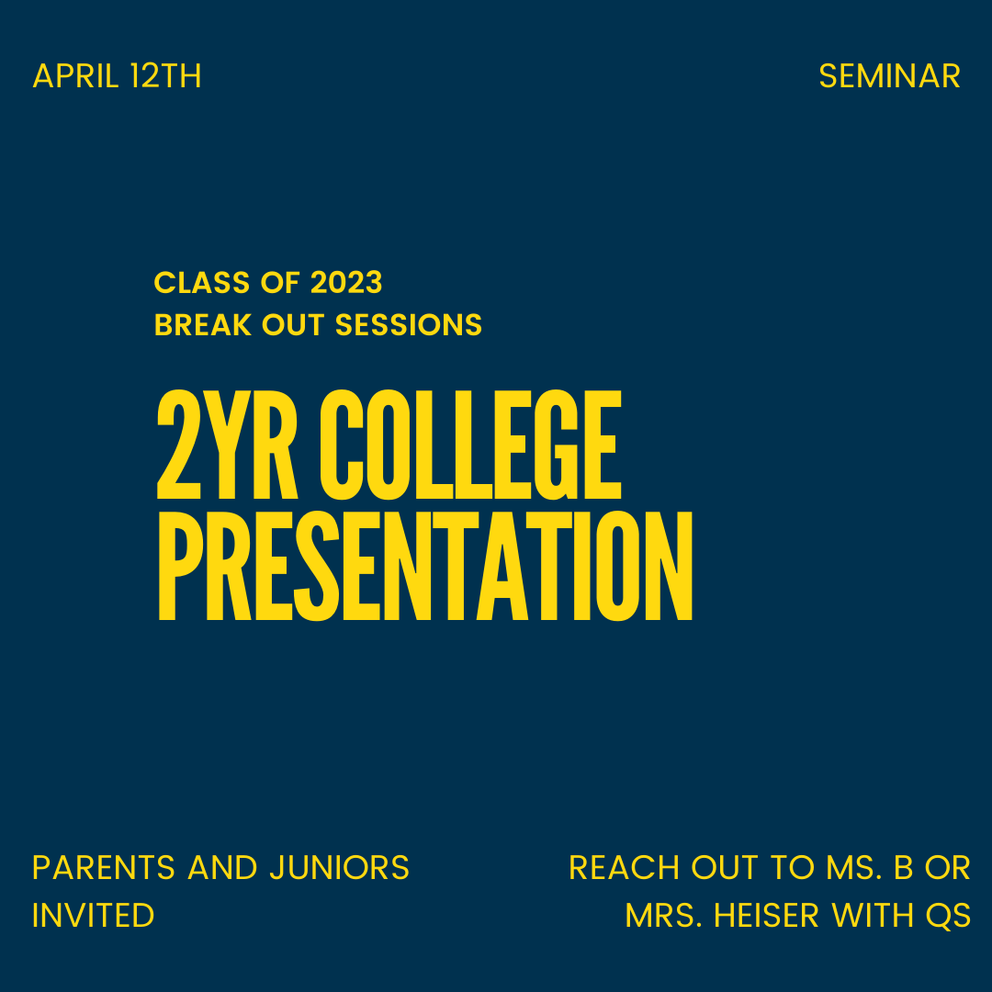
2 Year College Breakout Session with Mrs. Heiser
What: A presentation about community college. The presentation will also cover the fin. aid for 2 year college
All students who attend will be entered into a raffle to receive a $10 gift card to the place of their choice (location must be approved by Ms. B)

When: April 12th, 8:30am - 9:05am (Seminar)

Who: All interested juniors and their parents (attendance is not required)

If you have any questions don't hesitate to reach out to Lee Bernstein or Lisa Heiser

Upcoming Breakout Sessions/Junior Events:
April 21st: 4 year college pathway
April 28th: Junior Parent Evening (more details to come)
Can't attend a break out session but are interested in the content, reach out to Ms,.Bernstein or Mrs. Heiser to set up a meeting

