Dear Parent,

(_) School is using Reading Plus to help students become better readers. Reading Plus is a web-based program that helps students to develop the skills they need to be proficient readers and independent learners. Through regular Reading Plus practice, your child will begin to read faster and understand more of what [he/she] reads. All of the content is based on the new Common Core State Standards that will excel students to become College and Career Ready. To learn more about Reading Plus, visit their website: http://www.readingplus.com/.

In school your child has completed the InSight Placement Test that calculated their reading comprehension and vocabulary levels. We are requesting that each student log into Reading Plus: login.readingplus.com three to four times during a seven day week. Students can log in daily if they wish to excel in the program.

Once the Start-Up Process for determining the student’s I-Rate (Independent Reading Fluency Rate) and the G-Rate (student’s Guided Silent Fluency Rate) is completed, the student will be assigned a prescribed number of assignments to complete over a seven day period. The assignments can be completed in any order. The week begins on Monday and ends on Sunday (midnight). Your child can complete Reading Plus assignments on your home computer or tablet. The program will keep track of assignments completed with 80% or higher comprehension and assignments still due. Assignments not completed in the seven day period will roll over to the next week and will be added on as “Make Up” work. Encourage your child to complete additional work in order to earn Bonus points! *Note: Only two SeeReader assignments can be completed in a single day.

How to Log In:

Step 1 - Go to login.readingplus.com

Step 2 - Press the Student Login button

Step 3 - Enter Site Code: _____________

Step 4 - Type Username: Student ID
Step 5 - Type Password: ______________

How to Check Your Child's Work
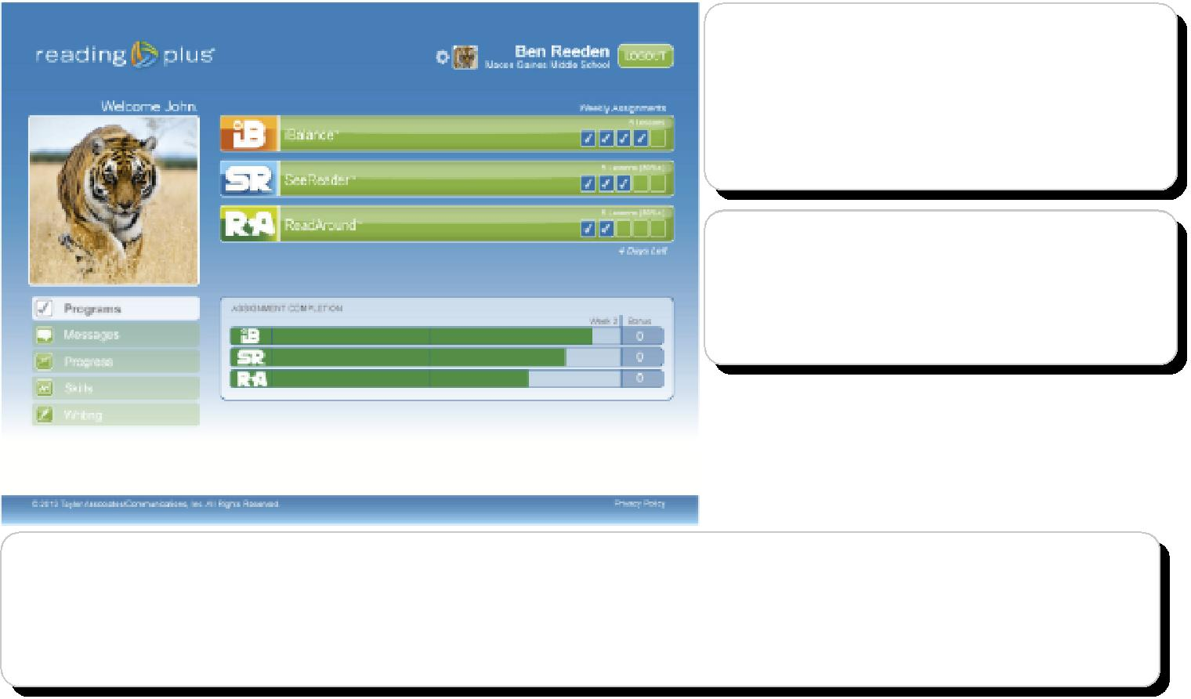
Checkmarks in these boxes indicate that assignments have been completed. Empty boxes indicate assignments still due.

View overall assignment completion and how many bonus lessons have been earned.

Press the program logos in the assignment completion widget to view your child's comprehension scores on lessons completed. In SeeReader (SR), only scores of 80% or higher count as completed assignments.
SeeReader  15 minutes | Guided Reading and Independent Reading Passages with Comprehension Questions. Only two (2) SR passages can be completed in one day. Maximum is 14 during the seven day week.  Every 8th lesson will be in the Independent-Rate format.  - 80%+ accuracy = 1 complete assignment  - Two 80%+ scores in a row = Combo  - To move up a Level, students need to complete 3-7 Combos.  - Three 80%+ scores in a row = Power  - A power is worth 10 points and can change a 70% to an 80%.
ReadAround  10 minutes | Vocabulary Building – 200 Words in each level.  - Each word requires up to 7-10 points for mastery  - 60 points = 1 Assignment  - 180-200 words = 1 Level
iBalance  5-10 minutes | iBalance is designed to support the development of a student’s visual perceptual skills, particularly visual perceptual span, visual memory, and left-to-right scanning ability. iBalance consists of two activities, Scan and Flash.  - 120 points = 1 Assignment  - 1 assignment = 70 points in Flash + 50 points in Scan.

For Reading Plus to run properly on a computer, please use these Technical Requirements as a guide.
Technical Requirements : http://www.elsystems.com/RPV4TechSpecs

Our school has a motivation plan in place. Students who complete their assignments will be recognized for their achievements. We are looking forward to Celebrating Success with your child.

Please contact me if you need help or have any questions.

Respectfully,

