Georgetown County Association of Educational Office Professionals

SCAEOP Executive Board Meeting

The Executive Board for SCAEOP met Saturday morning in Georgetown at the J. B. Beck Center. Meeting started with a member meet and greet. Dr. H. R. Dozier, Superintendent for GCSD, opened the meeting with welcome and greetings. GCAEOP President Judy Cooper also greeted and thanked the Board Members for coming to Georgetown. Local members Tina-Gilliard Rice, CEOE and Claudia Cohen, CEOE serve as members of the State Executive Board. Senator Ronnie Sabb was invited to come and speak to the Board Members. President Cooper would like to thank everyone for the donations given.

 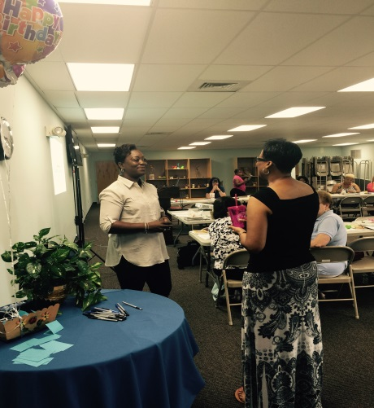

 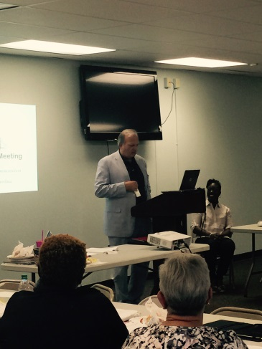

gcaeop

We are Jewels, Let’s Keep Shining 

Issue No. 2

Local members needing help with the PSP Program contact

Tina Gilliard-Rice, CEOE

[tgilliard-rice@gcsd.k12.sc.us](mailto:tgilliard-rice@gcsd.k12.sc.us)

Professional Standard Program

**NAEOP Webinars**

NAEOP is proud to announce that beginning in September, 2015, we will offer webinars for members and nonmembers to help them get educational credits and/or in-service points toward their Professional Standards Program certification.  The tentative schedules for the webinars are as follows:

•         September 24, 2015                The Professional Standards Program In-Depth

•         October 22, 2015                    Dealing with Difficult People

•         November 12, 2015                Effective Time Management

•         February 18, 2016                   Enhancing Your Leadership Skills

•         March 17, 2016                       Social Media in the Educational Setting

•         May 12, 2016                          Confidentiality, Freedom of Information and Other

Rules/Regulations

Webinars will be offered at either 12 noon to 1:00 pm Eastern Standard Time or 2:00 to 3:00 pm Eastern Standard Time with the participant choosing which time will work best for them.   All webinars will be recorded and those links will be made available to participants two days after the live presentation via You Tube video.  If you are unable to participate in the live presentation you will be able to link to the presentation via You Tube two days following the live presentation.  Cost will be $125 for members for the series of six (6) classes.  Nonmembers will pay $175 for the series of six (6) classes.  Full registration will entitle the participant to six (6) one hour webinars, handouts where applicable, links to webinars after two days of live presentation and PSP credit.

Participants will receive six (6) hours of Professional Standards Program Educational Credits for successfully completing the series and will receive a certificate upon completion of the courses.

Registration is available online at [www.naeop.org](http://www.naeop.org) under the events tab or by completing the enclosed registration form and returning it by mail, fax or email.

Debbie Geib

Executive Director

National Association of Educational Office Professionals

316-942-4822

[www.naeop.org](http://www.naeop.org)

**Georgetown County AEOP**

**2018 Church Street**

**Georgetown, SC 29440**

News Letter

**Sydney Rice**

[srice@gcsd.k12.sc.us](mailto:srice@gcsd.k12.sc.us)

Web Masters

**Kathleen Elmore**

[kelmore@gcsd.k12.c.us](mailto:kelmore@gcsd.k12.c.us)

**Daphne Smith**

[dsmith@gcsd.k12.sc.us](mailto:dsmith@gcsd.k12.sc.us)

Issue No. 2 Friday, September 04, 2015