2020-2021
Liberty County School District
Back to School Plan
Due to uncertainty caused by the Coronavirus (COVID-19) global pandemic, the school district of Liberty County has created this document to inform you of the preparations and plans for the 2020-2021 school year.
District leaders and school principals have been studying the possibilities for providing instruction to our students when the next school year begins in August. These discussions have been centered around health-related guidance provided by the Centers for Disease Control and Prevention (CDC), the Florida Department of Health in Liberty County (DOH-Liberty), the Florida Association of District School Superintendents (FADSS), the “Safe, Smart, Step-by-Step Plan for Florida’s Recovery” put together by the Re-Open Florida Task Force, and the results of the parent/staff survey. This plan may be modified to fit current circumstances (Circumstances surrounding the Coronavirus (COVID-19) are rapidly changing). Given the size and scope of our current challenge, we must make tough choices. We may make mistakes but will adapt quickly as variables change.

Additions to this plan added 8-20-20 are noted in “blue”

COVID-19 District Response Matrix
Plan for increased mitigation measures or school closure
Level of Spread  In consultation with state and local officials. | Plan A:  Minimal Spread  0-10% (or 2 students per class whichever is more)  - Class  - Grade level  - Building  - School  - District |  |  | Plan B:  Moderate Spread  11%-20% (or 3 students per class whichever is more)  - Class  - Grade level  - Building  - School  - District |  |  | Plan C:  Substantial Spread  21% & up  - Class  - Grade level  - Building  - School  - District
Instructional Model  In consultation with state and local officials. | Option 1:  Traditional | Option 2:  Liberty Virtual  (PAEC Franchise) | Option 3:  iLiberty  Virtual | Option 1: Traditional | Option 2:  Liberty Virtual (PAEC Franchise) | Option 3:  iLiberty Virtual Using synchronous or asynchronous instruction by Liberty County Teachers | Option 1: Liberty Virtual (PAEC) | Option 2:  iLiberty  Virtual  Using synchronous or asynchronous instruction by Liberty County Teachers
Response  In consultation with state and local officials. | School Campus Open  - Social distancing  - Face coverings (mask or face shield) strongly encouraged at school  - Face coverings (mask or face shield) will be required on the school bus and during transitions.  - Safety dividers optional  - Regular hand washing  - Staying home when sick  - Extracurricular activities permitted  - Lunchroom @ 75% capacity  - Playgrounds open with safety protocols in place |  |  | School Campus Open  - Social distancing  - Face coverings (mask or shield) required at school and on the bus with scheduled breaks. Kg-3rd classes exempt expect during transitions and while on school bus.  - Safety dividers required  - Regular hand washing increased  - Staying home when sick  - Extracurricular activities may or may not be permitted (monitor more closely positivity rate or symptomatic rate within activity groups)  - Lunchroom @ 50% capacity  - Playground/PE will be limited to small groups. No cross-class groups allowed. |  |  | School Campus Closed  - Extracurricular activities suspended  - Staff may or may not report to campus
Considerations to determine increased mitigation measures and/or closures:
Daily review of symptomatic students/staff, students/staff tested positive, and students/staff positive exposure by classroom, grade level, building level, school and district.
Metrics:
- The numerator is the number of students/staff that were sent to school nurse with Covid-19 like symptoms and as a result were sent home + number of students/staff who did not pass entrance screener + number of students/staff who were kept home due to symptoms.
- The denominator is the total number of students/staff for each of the areas listed above.
Daily review of community positivity rate for Covid-19 with special consideration for number of school age students testing positive. Data source will be the Florida Department of Health in Liberty County (DOH-Liberty).
Data spreadsheets for calculating the percent of symptomatic students and staff will be maintained by a designated school administrator at each school site. This data will also be reviewed daily to determine minimal, moderate or substantial spread. Data will be reported to the Department of Health Contact and Superintendent daily to determine course of action needed.

Mitigation Efforts Will Continue
Parents, please be assured that regardless of the plan, the School District of Liberty County is committed to practicing, teaching and monitoring serious mitigation strategies as prescribed by local, state and national health officials, such as: School Entry Screening, Temperature and Symptom Checks, Appropriate Social Distancing, Masks and Sanitizer Dispensers. Other mitigation measures are routine handwashing for students and staff, routine cleaning and disinfecting, structured movement in hallways, reduction of large gatherings and limited visitors, etc.
For further information see Appendix A (CDC Guidelines for K-12 Schools) & Appendix B (Safe.Smart.Step-by-Step Plan for Florida’s Recovery)

COVID-19 School Checklist
Our top priority is the safety of students and staff while delivering quality instruction.
TEAM approach: Together Everyone Achieves More
The following list contains guidelines for opening the schools during the 2020-21 school year:
COVID-19 School Entry Screening Protocols: (Refer to COVID-19 Screening/Exposure Flow Charts)
- Each school will have one assigned Department of Health point of contact.
- Nurse/health staff and other site staff members designated by the Principal, utilizing Personal Protective Equipment (PPE), will conduct a daily screening at the entrance to the school using Appendix C: Simple screening/Questionnaire. Everyone is encouraged to self-report symptoms of illness and positive test results.
- Designated entrances will be used, and social distancing will be maintained to the greatest extent possible.
- Staff will be signed in at the designated entrances and temperatures recorded.
- All staff and students entering the school/building will have their temperature checked and will be screened for other identified symptoms. Students arriving by buses are exempt as they would have already had a screening before getting on the bus. Car riders will be checked in the car drop off area prior to exiting the car.
- If anyone has a temperature of 100.4 degrees or higher or exhibit one or more of symptoms listed on the DOH Daily Screener, they will not be admitted into the school/building. Students who run a fever or exhibit one or more of listed symptoms while at school will be kept in a designated waiting room while waiting for pick up.
- If the symptomatic student has siblings at the school, he/she will also report to the waiting room. The affected student and siblings will be sent home to quarantine for no less than 10 days or until affected student has a negative PCR covid-19 test or has documentation of a confirmed other illness that caused the symptoms. Refer to the DOH Screening document.
- Masks will be available at entrances if needed by staff and/or students. Personal masks worn by students must be compliant with the Student Code of Conduct/Dress Code. Plastic face shields and/or gloves may also be worn by anyone if they choose.
- No volunteers or visitors will be allowed on school campuses until further notice during this pandemic. Parents will have limited access to school sites.
- Essential vendors (including cafeteria vendors) will be allowed entry if approved by the Principal and temperature check and screenings are conducted using appendix C. Masks will be required while on campus. All vendors/contractors will be required to sign in once they are allowed entry.
- Any student/staff arriving late will go through the same screening process as outlined above. Any parent/guardian dropping off student will need to stay until screening is done.

COVID-19 School/Classroom Protocols:
- Procedures for hallway movement will be implemented in all areas and noted with appropriate signage.
- Frequent handwashing, appropriate mask use and social distancing procedures will be taught initially and then reviewed and practiced daily.
- Large gatherings of students and staff will be reduced around campus as specified in the Response Matrix.
- Classroom seating will be spaced at a reasonable distance. Seating Charts maintained.
- Students will eat lunch in the cafeteria or other designated areas. The cafeteria will not exceed capacity of 75% or 50% (based on response matrix). The remaining 50%/25% of students will utilize outdoor seating, hallways, or other designated areas. Staggered schedules will be implemented to reduce numbers in the cafeteria.
- Meals will be served in closed food containers.
- An alternative to recording student lunch numbers will be used instead of the keypads.
- Employees will disinfect their own personal workspace (desk, phone, etc.) regularly.
- Teachers will disinfect frequently touched areas in between classes.
- Teachers and students will limit visits to other classrooms outside of their team or grade level.
- PE teachers/staff will wipe/spray down all PE/playground equipment after each class using designated disinfecting solution.
Extra – Curricular Activities:
- Coaches/activity leaders will clearly communicate expectations for participating students.
- Staff and students will clean and disinfect frequently touched surfaces.
- Social distancing will be maintained during activities as much as possible.
- The number of individuals in a confined space will be based on CDC guidelines.
- Follow FHSAA Guidelines regarding athletics.
- Students will provide their own water bottles and towels. No other items will be shared.
- Temperature checks and screenings will be conducted daily using Appendix C Daily Screening/Questionnaire.
- Back to School Activities and Events will be suspended on campus until further notice. Each school will create an alternative plan to creatively “Welcome” students and families for the school year as well as for other typically scheduled events (i.e. Awards Day, parent meetings, etc.)

Confirmed COVID-19 Case in a School or on a Bus: (Refer to COVID-19 Now What Flow Chart)
Any school in the district might need to implement short-term closure procedures regardless of community spread if an infected person has been in a school building or on a school bus. In addition, if there is substantial community-wide transmission, all schools or some schools may be required to close temporarily. If this happens, the CDC recommends the following procedures regardless of the level of community spread.
- Coordinate with local health officials. Once learning of a COVID-19 case in someone who has been in the school, immediately notify local health officials. In the case of a county or community-wide cases, local health officials will notify the Superintendent/Designee. Local health officials will help administrators determine a course of action for their programs or schools.
- Dismiss students and staff for the number of days determined by local or state officials. A school(s) closure allows time for the local health officials to gain a better understanding of the COVID-19 situation impacting the school or schools. This allows the local health officials to help the district determine appropriate next steps, including whether an extended dismissal duration is needed to stop or slow further spread of COVID-19.
- Communication with staff, parents, and students and coordination with local health officials to communicate dismissal decisions and the possible COVID-19 exposure.
Local health officials’ recommendations for the scope (e.g., a single school, multiple schools, the full district) and duration of school dismissals will be made on a case-by-case basis using the most up-to-date information about COVID-19 and the specific cases in the community.
During school dismissals, all extracurricular group activities, school-based afterschool programs, and large events (e.g. assemblies, spirit nights, field trips, and sporting events), will be cancelled. Staff, students and their families will be discouraged from gathering or socializing. This includes gathering at places like a friend’s house, favorite “hang out spot”, etc.
Confidentiality of the student or staff member are required by the American with Disabilities Act and the Family Education Rights and Privacy Act will be maintained.

Return to School Criteria for Staff/Students who have confirmed exposure to COVID-19 (Refer to the “Now What” flowchart) refer to the Florida Department of Health Daily Screening for Students and Staff flowchart and Decision tree for Symptomatic People in Schools.

Return to School Criteria for student/staff with fever of 100.4 or more who have not been exposed:
- If a student/staff runs a fever of 100.4 or more will be sent home. Student/Staff will NOT be able to return until fever free for 24 hours without medication. Students sent home will receive an excused absence. This section no longer applicable based on new DOH guidance and documents.

School Building and Maintenance:
- Clearly defined work schedules and checklists will be provided to custodial/maintenance staff.
- Schoolwide sanitation expectations will be clearly defined and provided by the principal, or his/her designee, to custodial staff.
- Completed checklists will be submitted to the Principal at the end of each workday.

Covid-19 School Bus Checklist
Register to Ride: To determine feasibility for social distancing on school buses parents will be surveyed to determine student ridership for the 2020-2021 school year. Further plans will be developed once ridership is determined.
Covid-19 School Bus Entry Screening Protocols:
- We strongly encourage parents/guardians to check your child’s temperature and assess their health at home before boarding the bus.
- Transportation staff (driver/aide/monitor), utilizing Personal Protective Equipment (PPE), will conduct a daily temperature checks at the bus stop.
- If any student has a temperature of 100.4 degrees or higher a parent/guardian will be notified if at the stop. If parent/guardian is not available, the student will be placed in a designated seat on the bus. When the bus arrives at school, the nurse/designated staff member will be contacted to place the student in a waiting room and follow school protocol to notify parent/guardian for pick up.
- Students are required to wear a mask while on the bus.
- If a student does not have a mask, one will be provided as they board the bus. Personal masks worn by students must be compliant with the Student Code of Conduct/Dress Code. Plastic face shields and/or gloves may also be worn by anyone if they choose.
- Ridership will be tracked using daily attendance rosters on school buses.
Covid-19 School Bus Seating Protocols:
- Social distancing on the bus is not feasible. Seating plans on school buses will be developed to the most reasonable plan as possible. Students are required to wear masks while on the bus.
- Siblings will share seats.

Instructional Options
Student Registration: All parents will be contacted via Parent Square survey or personal contact to determine educational choice options for the 2020-2021 school year. We will be requiring that our families commit to one of the following options for their children/students for the fall semester of the 2020-2021 school year by July 31^{st.}
After that, schools will be reaching out to the families that have not indicated their commitment. Our goal is to have confirmed feedback from all families in order to finalize staffing and scheduling process.
Educational Option choice will be a quarterly commitment.
Traditional Brick & Mortar School | Liberty PAEC Virtual | iLiberty Virtual
Traditional classes with CDC guidelines implemented to the best extent feasible.  Students are scheduled to return Aug. 31, 2020 and follow the district calendar and pacing guides | Parents complete “Home Education Program” registration form. Return form to school guidance counselors who will forward to PAEC. | Parent registers their child to participate in this program with their “home school” guidance counselor.  Students are scheduled to start Aug. 31, 2020 and follow district calendar and pacing guides.
Teachers will utilize the technology platform (Canvas) with students regularly to provide seamless transition in event of class/school shutdown. | PAEC works with parent to determine provider and student is registered for classes. | Technology platform (Canvas) utilized to deliver instruction and materials.
District teachers utilize text based and online curriculum for face to face instruction. | Uses PAEC franchise teachers who provide on-going support to parents/students.  Provider options: K-12; Apex Learning; CyberActive; eDynamic Learning; K12 Fuel Education, etc.  Adheres to curriculum developed by the Florida Virtual School System. | Uses Liberty County Teachers;  A student maintains district curriculum pacing as if attending in traditional setting. Students will follow the district school calendar and required “seat time” minutes per day.  Parent is responsible for making sure student participates daily & returns assignments, etc
ESE/ELL/504 Plan and other services remain in place. | ESE/ELL/504 plan services are provided through the franchise teachers and Liberty Co Teachers | ESE/ELL/504 plan and other services remain in place.
FTE: District receives all funding from this option | FTE: District receives partial funding from this option | FTE: District receives all funding from this option as student maintains school site enrollment.
Technology-Teachers and students will practice use of internet platforms during instruction. All students will be assigned a laptop for home use to have in place in the event of a class/school shutdown. | Technology: Laptops will be provided to all students. Internet stipend will be provided to the extent possible based on prioritized student need. | Technology: Laptops will be provided to all students. Internet stipend will be provided, to extent possible based on prioritized student need.
Enrollment/ “grace” period: 14 days | Enrollment/ “grace” period: 14 days | Enrollment/ “grace” period: 14 days
Student is eligible to participate in all district extracurricular programs. | Student is eligible to participate in all district extracurricular programs. | Student is eligible to participate in all district extracurricular programs.

Exceptional Student Education
The Exceptional Student Education (ESE) Department is committed to providing free and appropriate educational opportunities for students with disabilities, to the greatest extent possible in alignment with public health guidelines. To address the unique needs of students with disabilities, exceptional student education teachers and service providers will continue to work collaboratively with families to identify the most essential services for each student that can be provided both directly and indirectly in remote and in-person learning environments. We recognize that each student will have an individual plan based on the learning model selected that best fits their learning needs. When a determination regarding the learning model is made, we will be working with students and their parents to set detailed plans for the delivery of exceptional student education services.
Child Find and Evaluation:
Liberty County School District will continue to identify, locate, and evaluate students suspected of having a disability and in need of specialized instruction and related services. Some evaluation procedures can be completed in remoted learning situations, while other evaluations require in-person contact with students or observations of students in school setting. Liberty County School District will conduct evaluations remotely and in-person as feasible, while adhering to public health guidelines for the safety of students and staff.
Individual Educational Plan (IEP) Meetings:
Liberty County School District is committed to providing families an opportunity to have meaningful participation in the IEP development process. Whether in-person or an alternative format, such as phone, ZOOM virtual meetings, etc, IEP teams will partner with families to determine the most practical and safe format to conduct IEP meetings.
Delivery of Special Education and Related Services:
General education teachers, exceptional student education teachers, related services providers and families will discuss students’ individual needs and agree to a prioritized set of services that provide access to curriculum and enable progress toward IEP goals. In a hybrid setting, families and staff will discuss and agree to a set of prioritized services to be delivered in-person, when possible. Other services will continue remotely as specified in Liberty County’s distance learning plan and student’s temporary distance learning plan. Services for students with specific health or support needs will be addressed in collaboration with families on an individual basis.
Progress Monitoring and Reporting:
Exceptional Student Education teachers and related service providers will have in place consistent data collection and service log procedures for use across school based and remote learning environments. Collecting data and tracking the provision of services will assist educators and families in determining the effectiveness of instruction provided, monitoring student performance on IEP goals/objectives, and assisting IEP teams in making any necessary adjustments to instruction. Periodic reports on the progress the child is making toward meeting annual goals will be provided.

Accommodations and Modifications:
Accommodations and modifications are provided regardless of the educational setting. General education and ESE teachers will continue to collaborate to determine to provide accommodations and/or modifications, as outlined in the IEP and as appropriate considering the circumstances. The IEP team, (general education teachers, exceptional student education teachers, related service providers, and families), will work collaboratively to identify alternative solutions if it is determined an accommodation or modification is not appropriate or successful in a particular setting.
Confidentiality and Student Privacy:
Student Confidentiality and privacy laws are maintained in order to protect the privacy of education records. These regulations describe the obligations of the school district with regard to collection, processing, maintenance, quality, and disclosure of these records. All education records are protected, regardless of media format (e.g., written, electronic).
Exceptional Student Education teachers and related service providers use digital platforms approved by the district for secure access and confidential sharing of student information. In the event that services are being provided through distance learning, service providers will contact parents to discuss virtual options to determine parent preferences for the provision of services. As with an in-person observation in a classroom. Educators may set ground rules regarding non-student presence during virtual instruction.
Student Services
Student Service professionals include School Psychologists, School Social Workers, school-based Nurses, School Guidance Counselors, and Community Based Mental Health partners. The Student Service staff work together to provide support and services for all students.
One priority of these professionals is to provide comprehensive school-based mental health services and supports which address barriers to learning that impede student engagement, achievement, and optimal social-emotional functioning. In either a school-based or remote environment, Student Service professionals will continue to provide schools with the protocols and training necessary to support the mental health needs of students. The Student Service staff will provide ongoing support and resources to students, teachers and families.
Social Emotional Learning:
Student Services has developed a comprehensive Mental Health plan for providing in-person and remote social and emotional learning support. The Liberty County School Mental Health Plan is comprised of tiered interventions for students, including individual and group counseling and crisis prevention and intervention protocols.
As schools reopen, Student Service staff will provide support in meeting the social/emotional needs of students, addressing health needs, assisting parents, and communicating with outside agencies, etc.
- Mental health professionals will work with their teams and administrators to determine when their services will be provided in-person or remotely.
- Mental health professionals will provide or coordinate Individual and group counseling to any student in need.
- Mental health professionals will teach or co-teach social emotional learning strategies to help students adjust to the changes in their environment.
- Mental health professionals will use the referral process to secure help for students and families as needed.
Liberty County School District
CORONAVIRUS (COVID-19)
Principal Expectations for Back to School (2020-21)
- Share daily arrival procedures with staff. Designated staff will screen all employees upon arrival daily. Employees would not return to work if ill or have a temperature of 100.4 or higher. Staff will be sent home if they have a fever. All employees will enter through identified points of entry. (Refer to flow charts)
- Staff will wear masks when they are traveling throughout the campus.
- Convey social distancing requirements for classrooms and hallways. Ensure that directional hallway and social distancing signage are displayed throughout school.
- Share a schedule/calendar of required professional learning.
- Notify supervisor if staff member needs an ADA accommodation and contact HR to finalize details.
- Share daily procedures for bus arrival and departure (A busload of students who have been scanned will NOT need to be scanned upon arrival to school).
- Share daily procedures for students who have a fever or symptoms. Designate area where student will be monitored.
- Breakfast/lunch procedures – Establish routines/procedures to meet the needs of the school, following guidelines above.
- Dismissal procedures – Create specific procedures to ensure social distancing and supervision. Stagger the staff arrival/departure times to accommodate car riders, walkers, buses while ensuring social distancing.
- Teacher planning – Encourage teachers to collaborate daily but utilize social distancing.
- Playground Usage- Ensure that a daily cleaning schedule is created for playground equipment sanitation.
- Clearly defined cleaning schedule for custodians
- Schoolwide sanitation expectations- daily and weekly procedures- The Principal or designee will disseminate a checklist to be completed and submitted routinely at the close of the work shift.
- Communicate TEAM Approach – Together Everyone Achieves more. Our priority is the safety of students and staff while delivering quality instruction.
- Share procedures that will be implemented when an identified COVID-19 case is confirmed (see flowcharts DOH Daily Screening for Students & Staff and DOH Decision Tree for Symptomatic People in Schools). Our policies/procedures will remain consistent district wide.
- Clearly communicate expectations for sports, visual/performing arts, etc.
- Clearly communicate expectations for extended day programs.

District directors will implement these same procedures at the district site.

Appendix A:
CDC Guidelines for K-12 Schools
Since the spread of the novel Coronavirus in the United States, the Centers for Disease Control and Prevention (CDC) has been providing guidance to K-12 schools on how to protect students, teachers, administrators and other school staff.
The following is a brief summary of CDC guidelines specific to K-12 schools:
- Actively encourage employees and students who are sick or who have recently had close contact with a person with COVID-19 to stay home.
- Teach and reinforce handwashing with soap and water for at least 20 seconds and increase monitoring to ensure adherence among students and staff.
- If soap and water are not readily available, hand sanitizer that contains at least 60% alcohol can be used (for staff and older children who can safely use hand sanitizer).
- Face coverings should be worn by staff and students (particularly older students) as feasible and are most essential in times when physical distancing is difficult.
- Develop and implement procedures to check for signs and symptoms of students and employees daily upon arrival, as feasible.
- Employees, students and visitors should confirm that their temperature is less than 100.4o F (38.0o C) and confirm that they are not experiencing coughing or shortness of breath.
- Clean and disinfect frequently touched surfaces (e.g., playground equipment, door handles, sink handles, drinking fountains) within the school and on school buses at least daily or between use as much as possible.
- Rearrange student desks to maximize the space between students.
- Turn desks to face in the same direction (rather than facing each other) to reduce transmission (e.g., from talking, coughing, sneezing).
- Create social distance between children on school buses (for example, seating children one child per seat, every other row) where possible.
- Limit nonessential visitors. Limit the presence of volunteers for classroom activities, mystery readers, cafeteria support, and other activities.
- Encourage employees and students to take breaks from watching, reading, or listening to news stories about COVID-19, including social media if they are feeling overwhelmed or distressed.
- Promote employees and students eating healthy, exercising, getting sleep, and finding time to unwind.
For more information, please visit the CDC website at: https://www.cdc.gov/

Appendix B:
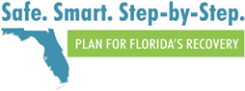

The “Safe. Smart. Step-by-Step. Plan for Florida’s Recovery” was put together by the Re-Open Florida Task Force and presented to Gov. Ron DeSantis. The “Step-by-Step” plan uses data-driven benchmarks that are reflected in four phases that define and guide re-opening initiatives in our state.
The following is a brief summary of the four phases.

PHASE 0:
Under Phase 0, Vulnerable Populations (individuals older than 65 years of age with a serious underlying
medical condition such as chronic lung disease, moderate-to-severe asthma, serious heart conditions,
immune-compromised status, cancer, diabetes, severe obesity, renal failure and liver disease) are urged to only leave their homes when necessary. Other individuals are urged to maximize social distancing in public and to limit socializing to groups of 10 or less people (which includes schools).

PHASE 1:
Under Phase 1, certain businesses can begin operating at reduced capacities. Vulnerable Populations should
continue to stay at home and adhere to social distancing when in public. Other individuals are urged to maximize social distancing in public and to limit socializing to groups of 10 or less people (which includes schools).

PHASE 2:
Under Phase 2, Vulnerable Populations should continue to stay at home and adhere to social distancing when in public. More businesses can begin operating at larger capacities and other individuals are asked to limit socializing to groups of 50 or less people (which includes schools).

PHASE 3:
Under Phase 3, Vulnerable Populations can resume public interactions but should practice social distancing.
Limitations for social gatherings are removed for other individuals (which includes schools).

Appendix C:
Daily Screening/Questionnaire:
- Screen for temperature less than 100.4
- Observe for cough: New uncontrolled cough causing difficulty breathing
- Observe for shortness of breath
- Ask if having diarrhea, vomiting, or abdominal pain
- Ask if have sore throat
- Ask if new onset severe headache, especially with fever
- Ask if had new loss of taste/smell
- Ask: Have you been in direct contact with anyone positive for Covid-19
- Ask: Have you traveled outside of the state/country.

Appendix E:
Contact Tracing Procedure
- Interview people with COVID-19 to identify if they had close contact with anyone during the time they may have been infectious
- Notify contacts of their potential exposure
- Refer contacts for testing
- Monitoring contacts for signs and symptoms of COVID-19
- Connecting contacts to services they might need during the self-quarantine period
To prevent further spread of disease, people who had contact with someone with COVID-19 are encouraged to stay home and maintain social distance (at least 6 feet) from others until 14 days after their last exposure to a person with COVID-19. Contacts should monitor themselves by checking their temperature twice daily and watching for symptoms of COVID-19. (Refer to attached flowcharts)
*reminder to send staff notification letter when applicable

Addition 8-20-20
Conducting Contact Tracing in a School Setting 8/14/2020
When a confirmed or probable case of COVID-19 is identified in a student, teacher, or staff member in a school setting, the case investigator should gather information to help determine close contacts and exclusion recommendations. Additionally, they will need to work with the school to conduct a thorough investigation and ensure the appropriate follow-up occurs. The following definitions are important to understand when conducting case investigation and contact tracing.
Definitions
Confirmed Case – a polymerase chain reaction (PCR)-positive case with or without symptoms Probable Case – an antigen-positive case or a symptomatic contact of a confirmed case
Infectious Period – a case of COVID-19 is considered infectious from two days prior to symptom onset, or specimen collection date for asymptomatic cases, through 10 days later
Close Contact – anyone who was within 6 feet of the case for 15 minutes or more while they were considered infectious, regardless of whether either person wore a cloth face covering or face shield.
Isolation – Applies to those who are sick or test positive for COVID-19 and involves staying home from work, school, and/or activities. Isolation lasts for at least 10 days after the onset of symptoms, 24 hours fever-free without fever-reducing medication, and an improvement of symptoms. For cases who have not had symptoms, isolation lasts 10 days from the day of specimen collection for their first positive test. In rare instance, (for example, if a person was very sick or has certain medical problems), isolation may last 20 days. Repeat testing is not recommended to decide when to end the period of isolation. Instead, determining when to end isolation should be based on the symptom-based criteria above.
Quarantine – Applies to those who are potentially exposed and involves staying home from work, school, and/or activities when a person is a close contact to someone with COVID-19. Quarantine lasts for 14 days from the last date of exposure to the case (unless a person develops symptoms, then they will be put in isolation). Negative testing does not release a person from quarantine.
Case Interview
The interview with confirmed or probable COVID-19 cases in K-12 school settings should address the following information requirements and should be input into Merlin within 24 hours:
- Date of symptom onset
□ If they did not have symptoms, date specimen for first positive test was collected
□ Reason they were tested (e.g., symptoms, contact to case, part of outbreak or cluster)
□ Date(s) the person last worked/attended school during their infectious period
□ Mode of transportation to and from the school (e.g., bus, carpool, etc.)
□ Before and after school activities (e.g., clubs, sports, etc.)
School Evaluation
The evaluation of the school for confirmed or probable COVID-19 cases in the K-12 school setting should address the following information requirements:
- When was the person on campus during their infectious period?
□ Whom did that person come in close contact with?
- Was that person with a single cohort in one classroom?
□ Was that person or classroom mixing with other people or classrooms?
□ Was there intermixing between groups or classrooms?
□ How were the classrooms set up (desk separation and spacing)?
The information gathered during the case interview and school evaluation will dictate the recommendations that need to be followed. Close contacts to the case should be notified by phone and possibly by letter regarding their potential exposure and advised of required follow- up actions. They should stay home and quarantine for 14 days from their last exposure to the case.
Depending upon the case’s movements and actions, the number of people considered close contacts will vary. For example, if the case was deemed to have spent limited time at the school while infectious, or strict cohorting and social distancing within the classroom is observed, very few students or teachers would need to be quarantined. If strict cohorting is done, but there is prolonged contact and some close interaction in the classroom, the teacher and all students in the classroom will likely be quarantined and the classroom temporarily closed for cleaning and disinfection. If the infected case was interacting with students and teachers throughout the school campus while infectious, a larger number of students and school personnel may need to be quarantined. More broad interventions may also be needed if investigations reveal untraceable transmission in the school setting.
Testing Recommendations
For staff and students who are close contacts to someone with COVID-19 and are asymptomatic, testing is not necessary, and they should be allowed to return to school after 14 days have passed from their last date of exposure to the case if they have remained symptom free.
K-12 schools and some staff may be designated as critical infrastructure, under the government facilities sector. While it is ideal that exposed staff self-quarantine for the 14-day period, there may be some circumstances in which asymptomatic staff that have been exposed, may return to work in less than the 14-days, if their duties cannot be filled by another individual. It is important that all staff returning under this scenario perform daily symptoms checks and do not return to work if symptomatic.
However, for staff and students who are close contacts to someone with COVID-19 and do develop symptoms within the 14 days, they should seek medical care and testing. If their COVID-19 test is negative, they can return to school after 14 days have passed since their last exposure to the case and if their symptoms have resolved. If their test is positive, they will be considered a case of COVID-19 and should follow the guidance for cases of COVID-19.
When selecting a testing laboratory, make sure results can be provided in 24 to 48 hours. As stated above, repeat testing is not recommended to decide when to end the period of isolation for COVID-19 cases. Indeed, repeat testing is not recommended within the first 3 months of the date of the original positive laboratory result, as this is unlikely to provide additional information useful for decision making.
Options for COVID-19 testing for staff/students who have been excluded from school:
- Staff/students obtain testing through their private medical provider
- Staff/students obtain testing at a public testing site in their community
- County health departments facilitate testing, particularly when school outbreaks occur or if testing is needed to support decision making, such as closing a classroom or a school. County health departments should consider consulting with the Bureau of Public Laboratories regarding testing at one of the state public health laboratories.
Cleaning and Disinfection
When a COVID-19 case has been in the school while infectious, the CDC recommends cleaning and disinfecting the building thoroughly by:
- Closing off areas used by the persons with COVID-19 and waiting as long as practical, if possible up to 24 hours, before beginning cleaning and disinfection to minimize potential for exposure to respiratory droplets
  - If possible, open outside doors and windows to increase air circulation in the area
- Cleaning and disinfecting all areas (e.g. offices, bathrooms and common areas) used by the person(s) with COVID-19, focusing especially on frequently touched surfaces (e.g. door handles)
  - Surfaces should be cleaned using soap (or a detergent) and water prior to disinfection
  - For disinfection, most common EPA-registered household disinfectants should be effective against the virus that causes COVID-19.

References and Resources:
CDC School Recommendations
CDC Cleaning, Disinfection and Hand Hygiene in Schools
Contact Tracing Guidance
Outbreak Guidance

Additional Screening Tool Below Added: 8-20-20

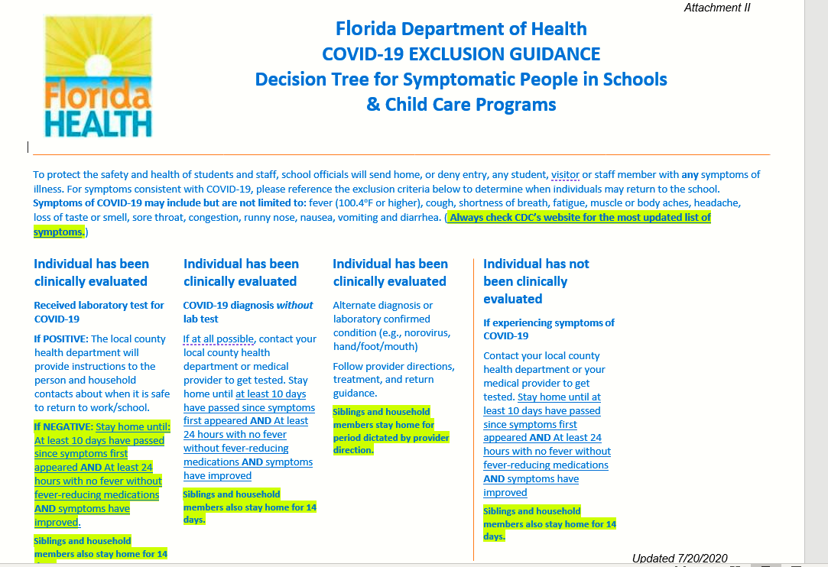

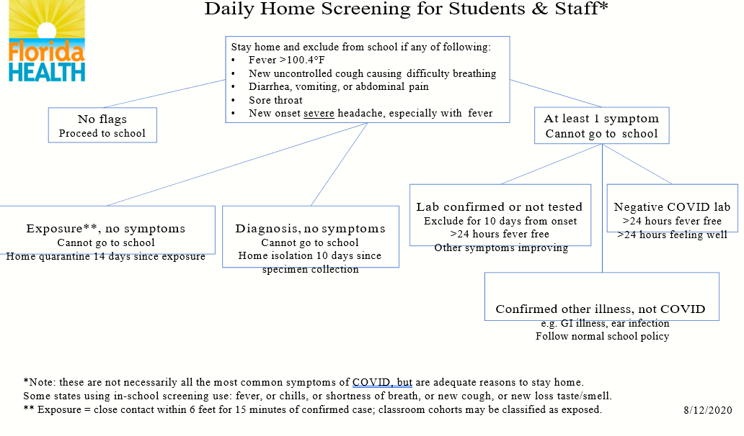

Flowcharts below DELETED 8-20-20
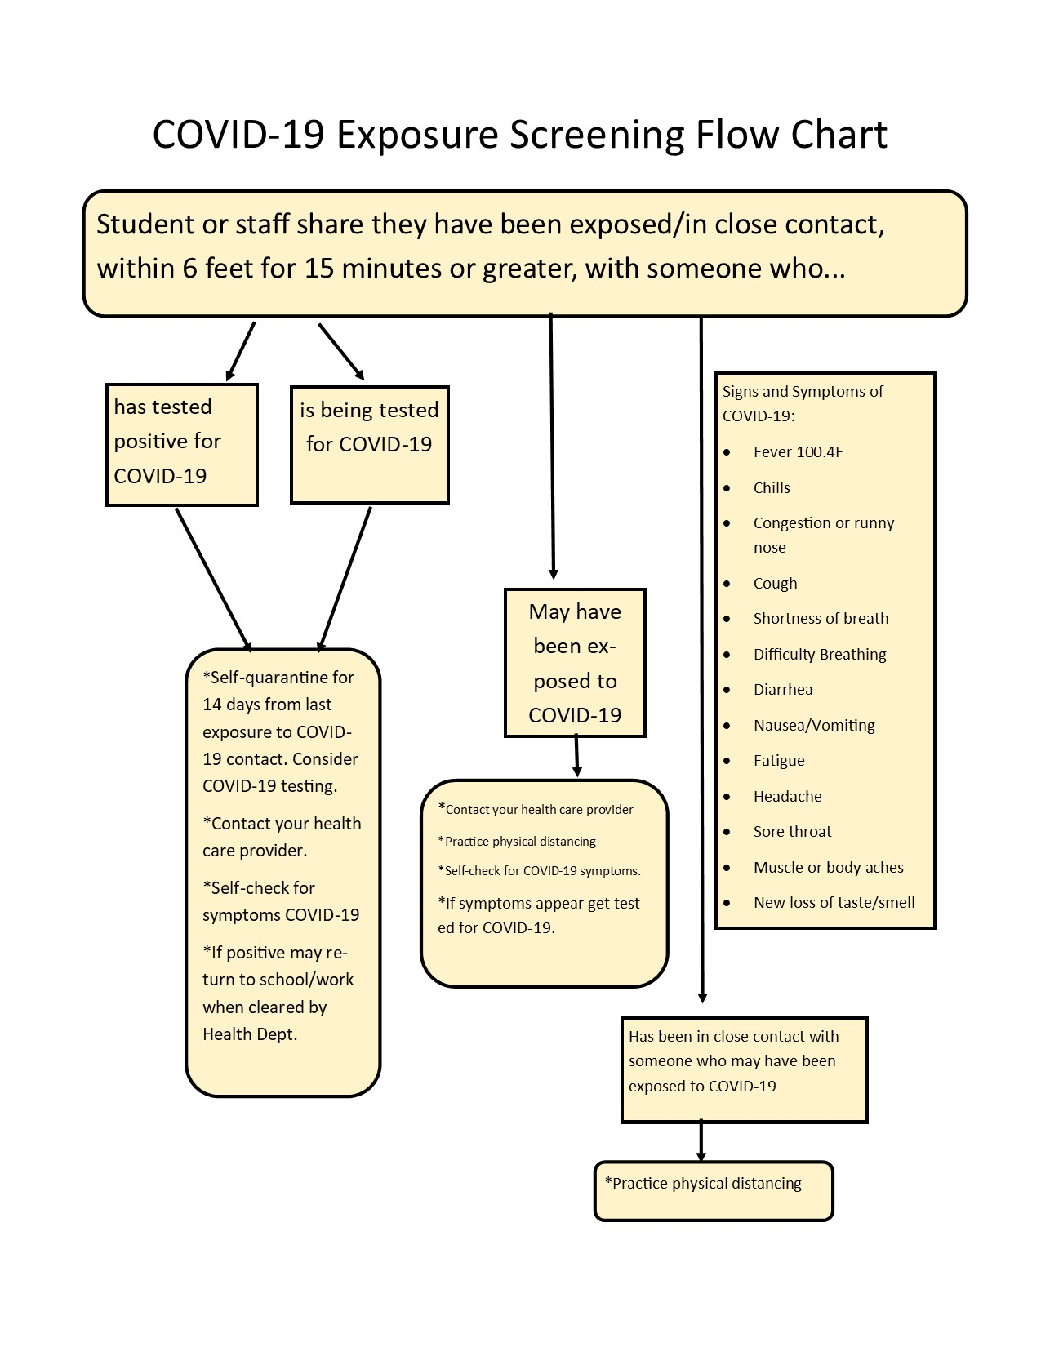
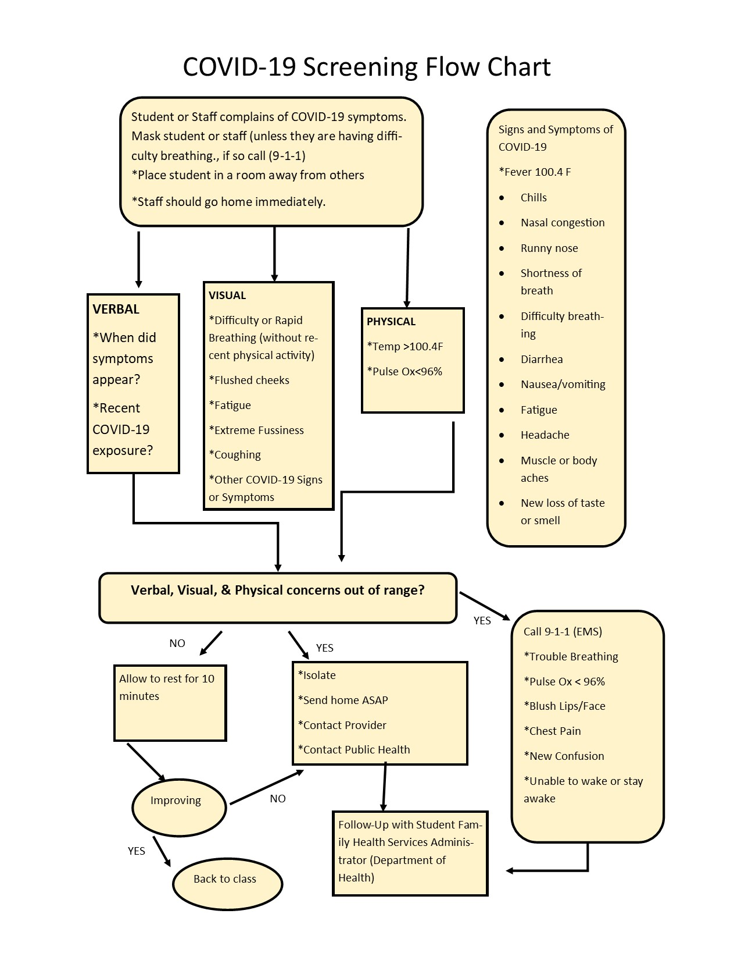
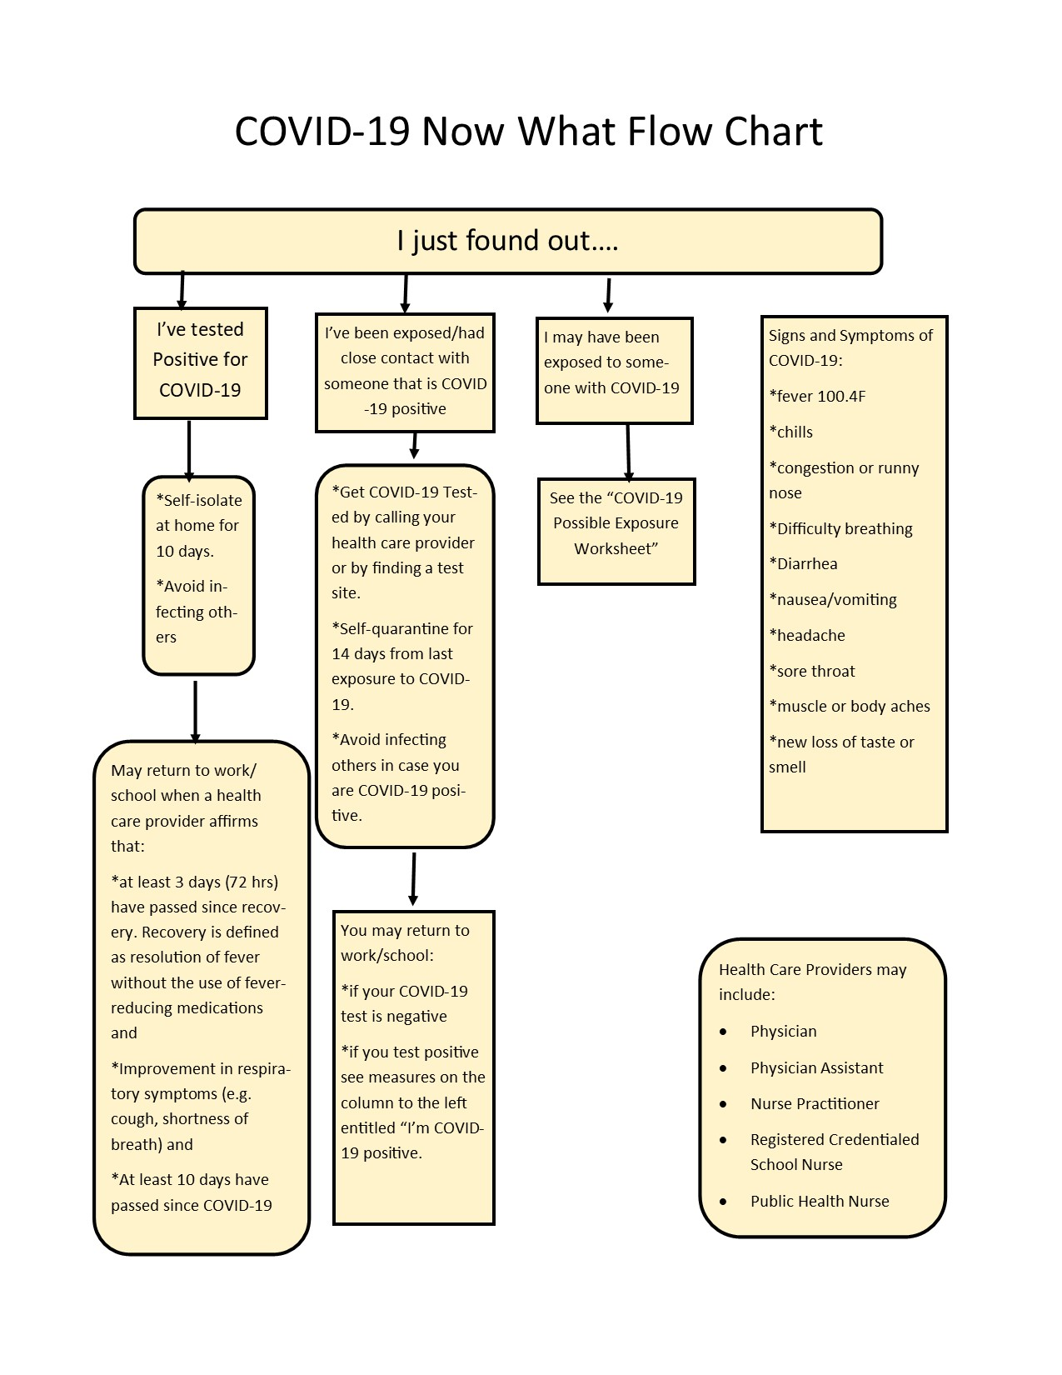
Contact Tracing Workflow chart below DELETED 8-20-20

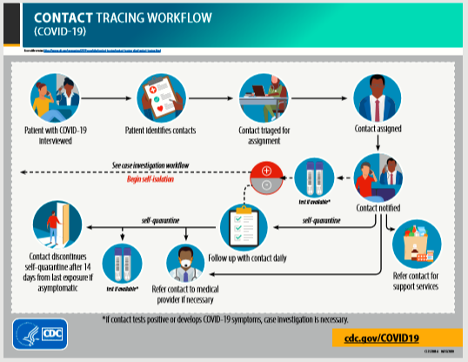

Staff Communication
Model Letters

Print on District/School Letterhead (Positive COVID-19 case-can work from home)
Date: _________________
Re: Positive COVID-19 Case
Mr./Ms.__________________________,
We are saddened to hear that you have tested positive for COVID – 19. As part of our district family, we are here to provide guidance for you as you move forward. What does this mean for you as a district employee?
- You are required to self- quarantine for a period of 10 days from onset of symptoms.

After consultation with your immediate supervisor, it has been determined that you can work from home during this ten-day period.
- Your supervisor will provide daily tasks that you can complete from home.

To return to work, you must satisfy the following requirements:
- You have quarantined for at least 10 days since symptoms first appeared AND
- It has been at least 24 hours with no fever without fever reducing medication AND
- Your symptoms have improved.
Your anticipated return date: __________________________.
If the conditions above are not met by this date, please contact your immediate supervisor for additional guidance.
We hope and pray that you will have a full recovery and look forward to having you back at work. If you have any questions, please feel free to contact me.
Sincerely,

David H. Summers
Superintendent
Liberty County School District

Print on District/School Letterhead (Positive COVID-19/cannot work from home)

Date:
Re: Positive COVID-19 Case
Mr./Ms.__________________________,

We are saddened to hear that you have tested positive for COVID – 19. As part of our district family, we are here to provide guidance for you as you move forward. What does this mean for you as a district employee?
- You are required to self- quarantine for a period of 10 days following onset of symptoms.
After consultation with your immediate supervisor, it has been determined that you cannot work from home during this ten-day period.
- Attached you will find documents that must be completed regarding this required absence from work.
To return to work you must satisfy the following requirements:
- You have quarantined for at least 10 days since symptoms first appeared AND
- It has been at least 24 hours with no fever without fever-reducing medication AND
- Your symptoms have improved.
Your anticipated return date is __________________________.
If the conditions above are not met by this date, please contact your immediate supervisor for additional guidance.
We hope and pray that you will have a full recovery and look forward to having you back at work. If you have any questions, please feel free to contact me.
Sincerely,

David H. Summers
Superintendent
Liberty County School District

Print on District/School Letterhead (Positive Exposure COVID-19/can work from home)

Date:
Re: Exposure to Positive COVID-19 Case
Mr./Ms.__________________________,
We are saddened to hear that you have been exposed to someone who tested positive for COVID – 19. As part of our district family, we are here to provide guidance for you as you move forward. What does this mean for you as a district employee?
- You are required to self- quarantine for a period of fourteen (14) days following the positive exposure.
After consultation with your immediate supervisor it has been determined that you can work from home during this fourteen (14) day period.
- Your supervisor will provide daily task that you can complete from home.
To return to work you must satisfy the following requirements.
- You have quarantined for at least 14 days since symptoms first appeared AND
- It has been at least 24 hours with no fever without fever-reducing medication AND
- Your symptoms have improved.
Your anticipated return date based on your exposure or positive diagnosis is ____________________.
If the conditions above are not met by this date, please contact your immediate supervisor for additional guidance.
We look forward to having you back at work. If you have any questions, please feel free to contact me.

Sincerely,

David H. Summers
Superintendent
Liberty County School District

Print on District/School Letterhead (Positive Exposure COVID-19/cannot work from home)

July 28, 2020
Re: Exposure to Positive COVID-19 Case
Mr./Ms.__________________________,
We are saddened to hear that you have been exposed to someone who tested positive for COVID – 19. As part of our district family, we are here to provide guidance for you as you move forward. What does this mean for you as a district employee?
- You are required to self- quarantine for a period of fourteen (14) days following the positive exposure.
After consultation with your immediate supervisor it has been determined that you cannot work from home during this fourteen (14) day period.
- Attached you will find documents that must be completed regarding this required absence from work.
To return to work you must satisfy the following requirements.
- You have quarantined for at least 14 days since symptoms first appeared AND
- It has been at least 24 hours with no fever without fever-reducing medication AND
- Your symptoms have improved.
Your anticipated return date based on your exposure or positive diagnosis is ____________________.
If the conditions above are not met by this date, please contact your immediate supervisor for additional guidance.
We look forward to having you back at work. If you have any questions, please feel free to contact me.

Sincerely,

David H. Summers
Superintendent
Liberty County School District

Talking Points for Educational Options

Talking Points for Educational Options:
Option 1: Traditional Brick and Mortar (Face-to-Face Classroom Instruction)
At this time, based on current information and guidance, the first day of school for students will be August 31st, with Health and Safety Guidelines implemented as outlined in the Return to School Plan. Schools will be implementing physical and social distancing measures to best fit the needs and spaces of their school. Masks are strongly encouraged for ALL students and staff, especially during transportation and transitions, and when social distancing is not possible.
Option 2: Liberty Virtual (PAEC Franchise)
Liberty Virtual is a franchise of the PAEC Virtual Franchise. Liberty Virtual uses PAEC franchise teachers who provide on-going support to parents and students. Provider options include Apex Learning; CyberActive; eDynamic Learning; and K12 Fuel Education. Each of these providers follow the state standards. PAEC will work with parents to select a provider and register the student for classes.
Option 3: iLiberty
iLiberty is the districts innovative learning option for students who wish to have the experience of attending their enrolled school but working from home virtually. With this option a student's learning and instruction takes place online with teachers from their school or the school district. The student maintains school site enrollment and pacing. Teachers and students in grades K-12 will use the learning management system (LMS), Canvas. Canvas, allows a single, consistent platform to hold instructional content and materials, assignments and assessments, student feedback, and teacher/student and student/student communications for a course.

Option 1: Return to Traditional Classroom
The traditional classroom will look different this year due to social distancing and other measures that will be put in place for the safety of students and staff. As part of daily instruction teachers will utilize the technology platform (Canvas) with students regularly to provide seamless transition in the event of class/school shutdown.
A frequently asked question is, how will it be determined when classes, grade levels, buildings, school, or the district will be shut down? The following considerations will determine when increased mitigation measures or a partial or full closure is needed.
The following formula will be used to determine minimal, moderate or substantial spread of COVID-19 symptoms.
- The numerator is the number of students/staff that were sent to the school nurse with COVID-19 like symptoms and as a result were sent home + number of students/staff who did not pass entrance screener (example 100.4 temperature or other symptoms) + number of students/staff who were kept home due to symptoms.
- The denominator is the total number of students/staff for each of the areas listed above.
Minimal Spread is defined as 0-10% (or two students per class whichever is more) of students or staff at the class, grade level, building level, school or district that meet the criteria listed in the formula.
Moderate Spread is defined as 11% - 20% (or three students per class whichever is more) of students or staff meeting the criteria.
Substantial Spread is defined as 21% or more of students or staff meeting the criteria.
If a class, full grade, building, school, or district has 0%-10% of students and staff showing positive symptoms then the following measures will be taken; social distancing, face coverings strongly encouraged, safety dividers optional, regular hand washing, staying home when sick, extracurricular activities permitted, lunchroom @ 75% capacity, and playgrounds open with safety protocols in place.
If a class, grade, building, school, or district has 11%-20% of students and staff showing positive symptoms then additional measures will be taken to mitigate the spread, such as face covering would be required at school and on the bus, safety dividers would be required, regular hand washing would be increased, lunchroom capacity would be reduced, and more restrictions would be put in place for PE and playground activities.
If a class, grade level, building, school, or whole district has 21% or more of students and staff showing positive symptoms then the area meeting the 33% will be considered for shut down. Additional measures such as a review of community positivity rate for COVID-19 with special consideration for number of school age students testing positive will be considered.
These are the proposed guidelines; however, they are subject to change.

Option 2: Liberty Virtual (PAEC Franchise)
What services are provided?
Liberty Virtual, (My Virtual Classroom) is the name of the virtual franchise at PAEC that serves the Liberty County School District. Virtual students have day-to-day flexibility while following a traditional school calendar. Students may choose from the following educational providers; K-12, Apex Learning, CyberActive, eDynamic Learning and K12 Fuel Education.
Who can enroll?
Students in grades K-12 may enroll in virtual education courses either full-time or part-time, provided they meet state eligibility requirements outlined in 1002.45 F.S.
What can you expect if you choose Option 2, Liberty Virtual?
The school guidance counselor or another staff person at the local school will contact you to review the requirements for Liberty Virtual and assist with registration.
What can I expect after enrollment in Liberty Virtual?
PAEC will enroll your student in courses for segment 1 of the school year and a certified teacher will be assigned.
The assigned teacher will contact you within 2 weeks of registration.
To be successful in Liberty Virtual what is a student required to do?
- Work in all courses on a daily basis although work may be completed during non-traditional school hours, such as evenings and weekends.
- Complete 20% of each course segment within 28 days of submitting the first assignment. If the student does not complete this requirement they will be withdrawn from the course.
- Do their best and maintain passing grades.
- Reach out to their assigned instructor anytime there are questions or special assistance is needed.
- Stay organized and manage their work.
- Complete segment one of all courses before the end of the first semester and segment two by the end of the school year.
How can parents ensure that students are successful?
- Be available for instructor calls to discuss student progress.
- Respond promptly to emails from the instructor.
- Monitor your student's progress in all course work.
- Promote keeping a daily work schedule.
- Provide a place where your student may work without distraction.
- Be aware of district requirements if you are considering returning your student to the local school at any point during the school year.

Option 3: iLiberty
How do I determine the best educational option for my child?
iLiberty is the districts innovative learning option for students who wish to have the experience of attending their enrolled school but working from home virtually. With this option a student's learning and instruction takes place online with teachers from their school or the school district. The student maintains school site enrollment and pacing. Teachers and students will use a learning management system (LMS), that allows a single, consistent platform to hold instructional content and materials, assignments and assessments, student feedback, and teacher/student and student/student communications for a course.
If you can answer yes, to the majority of these questions then this option may be a good choice for your child.
- My child is highly motivated, a self-starter and is committed to the success of his/her education.
- My child understands there is a high degree of personal accountability for a successful learning experience.
- My child will be able to complete assignments during normal school hours each day.
- An adult is available in the home to support learning during school hours daily.
- My family has reliable internet in the home.
- Someone is available during the school day to trouble shoot computer/internet issues.
- My child has a space in our home that is appropriate for learning.
- My child has available supplies to support learning.
- I can provide transportation for my child to come to the school campus to participate in REQUIRED progress monitoring and state testing during the school year.
- I understand that my child will follow the same school calendar as brick and mortar students.
- I understand that free breakfast and lunch will be available to my child daily, however I must have transportation to pick up these meals.
- I understand that iLiberty is NOT an easier option for learning.
- I understand that iLiberty will provide both live and recorded lessons.
- I understand that teachers will answer questions, however NOT on demand.
- I understand that the same grading policies are in place for iLiberty and brick and mortar school.
- I understand that my child will be responsible for participating in state testing.
- I accept the responsibility of monitoring my student daily to ensure that assignments are complete.
- I understand that there will be a high degree of communication from teachers and the school through electronic formats.
- I understand that digital users have no right or expectation to privacy when using district technology and resources (including but not limited to privacy of content of personal files, emails, or record of online activity).

Virtual Procedures
Liberty Virtual and iLiberty

Process for Liberty Virtual
- Prior to parent meeting:
  - List student name(s) on the 20-21 SY Liberty Virtual Enrollment Roster.
  - Print the appropriate registration instruction sheet for the student’s grade level.

- During the parent meeting:
  - Have parent/guardian print, sign, and date the roster to confirm their election to enroll their child(ren) in Liberty Virtual.
  - Explain that the student’s enrollment status will be changed to home education.
  - Advise that student transcripts will be forwarded to Brenda Couch, Director, My Virtual Classroom at PAEC, who will assist with enrollment and registration.

- After parent meeting:
  - Data Entry person will change student status in Focus.
  - Student transcripts will be pulled and forwarded to Brenda Couch at Brenda.Couch@paec.org.
  - Keep/file the roster form in a secure location as this is the official district record of this action.

Please call Amy Combs at ext. 11247 with questions.

Liberty County School District

2020-2021 SY Home Education Program Registration Form
**Please return the completed form to appropriate Liberty County School Board personnel.
To comply with Section 1002.41(1), Florida Statutes, this form serves as the written notice of intent to home educate.
Date of Submission: ____________________
Parent/Guardian Name(s): ___________________________________________________
Physical Address: _______________________________________________________
Mailing Address (if different): _______________________________________________
Primary Phone Number: _______________________________________________
Secondary Phone Number: ____________________________________________
Parent/Guardian Email: _______________________________________________
Name of Home School Curriculum: ______________________________________
Name(s) of Student(s) Date of Birth Current School Grade Level
____________________ _____________ ____________________ ____________
____________________ _____________ ____________________ ____________
____________________ _____________ ____________________ ____________

_______________________________________________ ______________________________
Signature of Parent/Guardian Date

Signature indicates that all information is correct and submitted by the legal parent/guardian.

Liberty County School District

Notice of Termination of Home Education Program

This letter serves as notice that I do not plan to operate a home education program during the ___________ school year. Below are the names of children who are no longer enrolled in home education.
________________________________________________________________________________________________________________________________________________________________________________________________________________________________________________________________________________________

_______________________________________________ ______________________________
Signature of Parent/Guardian Date
Return within 30 days of termination date to:

Gay Lewis
Liberty County School Board
12926 NW County Road 12
Bristol, FL 32321

20-21 SY Liberty Virtual Enrollment Roster
School:______________________________

Student(s) | Parent/Guardian | Signature | Date

iLiberty Enrollment Agreement
2020-2021
As the parent(s)/guardian(s) of ___________________________________________________ (Print Student’s name)
I understand that iLiberty requires my child to meet all conditions that foster a successful online education. During the first 14 days of my child’s activation and at the end of each quarter thereafter, he/she will be evaluated by teachers and guidance based on the conditions listed below. Students may only switch to Brick and Mortar at quarter breaks and the transfer form must be submitted one week prior.
Conditions defining a successful online student: (Initial each line)
_____ Maintain required weekly pace and progress in all courses.
_____ Engage in coursework on a daily basis with parental supervision.
_____ Establish regular communication with all teachers via working email, phone and/or ParentSquare.
_____ Keep all appointments for Discussion Based Assessments, conferences, and testing.
_____ Office Hours are required if grades are below “C” and/or behind pace.
_____ Provide transportation and attend all state/district standardized testing and progress monitoring benchmark testing.
_____ Maintain academic integrity through the submission of authentic, original work.
_____ Commit to completing the quarter-long plan.
_____ Honor all rules and procedures established by iLiberty and Liberty County School District as outlined in the Student Handbook and Pupil Progression Plan available at www.lcsb.org.
Meeting the above listed conditions is a requirement for continued enrollment.
___________________________________ ____________________________________
Parent/Guardian Signature/Date Student Signature/Date
___________________________________ ____________________________________
Parent/Guardian Name (Print) Student Name (Print)
Time and Learning Requirements:
Grade | Recommended Hours Per Day | Recommended Hours Per Week
K – 3 | 4 – 5 | 20 – 25
4 – 8 | 5 – 6 | 28 - 30

NOTICE OF INTENT TO TERMINATE iLIBERTY VIRTUAL INSTRUCTION PROGRAM
* Must be submitted one week prior to the end of the quarter
Dear Superintendent:

It is my intent to terminate the iLiberty virtual school program(s) of the following child(ren):
Student’s Full Name(s) | Student Number | Parent Last Name | School Name  (if returning to school)

The reason is (check one):
O The child(ren) has/have been or will be enrolled in a public, parochial, or private school.
Name of school: _________________________________ Phone: __________________
O The curriculum requirement of the iLiberty Instructional Program does not meet the needs of the child(ren).
O The child(ren) will no longer reside in Liberty County, Florida. The new residence will be in:
__________________________________________________________________________
County City State
O Other: ____________________________________________________________________
Until a student graduates or is 18 years old, he/she must be registered either in a public, private, or home education program in order to retain a driver’s license.
Submitted by: _________________________________ ____________ __________________
(Parent/Guardian signature) Date Phone
Address: ______________________________________________________________________
Street City State Zip

iLiberty Academic Integrity Policies Agreement
2020 – 2021

Academic integrity is the code of conduct for turning in assignments and completing assessments in education. It includes the ethical policies of honesty and the avoidance of cheating or plagiarism. iLiberty expects a full commitment to academic integrity from each iLiberty student.
Academic Integrity means:
_____ Students submit their own work for assignments and assessments.
_____ Students use citations to reference published work.
_____ Students do not receive unauthorized assistance on assignments and assessments.
_____ Students do not provide unauthorized assistance to other students.
_____ Students will not misuse content from the internet or other published source.
_____ Parents will supervise students to adhere to the rules of academic integrity.

iLiberty takes the importance of original student work very seriously because academic integrity is a fundamental value of a quality academic program where student learning takes place. As a result, iLiberty utilizes several plagiarism detection tools that will compare your work against the work of students in our database, as well as work found on the internet. Failure to follow the rules of academic integrity may result in parent conferences, proctored exams, grade deductions, zeros for assignments or assessments, failure of the course and expulsion. See the Liberty County School District Student Handbook for additional details.
I understand the iLiberty rules and policies of Academic Integrity and will abide by the rules as stated.
___________________________________ ____________________________________
Parent/Guardian Signature/Date Student Signature/Date
___________________________________ ____________________________________
Parent/Guardian Name (Print) Student Name (Print)

iLiberty Expectations and Responsibilities

Parent Responsibilities:
In lieu of the daily presence of a face-to-face teacher, parents should take the lead in monitoring the students through the curriculum, submission of work samples, assignments, online class sessions, producing projects, reviewing for quizzes and tests, as well as making sure they participate in the state assessments.

- Maintain contact with teachers and staff through ParentSquare, email, phone contact and provide timely updates to phone numbers and email addresses.
- Participate in monthly contact with teachers.
- Use Canvas resources to become familiar with utilization of Canvas as a Learning Management System (LMS).
- Support students with lessons when necessary and monitor virtual conferencing.
- Supply help to student(s) when troubleshooting problems.
- Provide transportation to all required state and district testing.
- Log into parent account weekly to monitor progress (ParentSquare, Focus, Canvas etc.).
- Provide a quiet learning environment conducive to a virtual school setting.
- Provide support/motivation to the student(s).
- Review and sign electronic syllabus (student and parent) if required by instructor.
- Complete Academic Honor Code Quiz with students if required by instructor.
- Monitor and maintain academic integrity.

The parent shall be responsible for their child’s school attendance as required by law. In iLiberty, daily/weekly assignment submissions, weekly virtual office hours attendance and daily/weekly communication with teachers equate to attendance.

Student Responsibilities

The goal of every child should be that of a “model student”. A model student is expected to be present at school every day, follow scheduled courses, and demonstrate appropriate behavior and a readiness to learn. Student’s responsibilities include:

- Log into iLiberty courses on a daily basis in order to maintain enrollment and be considered in attendance. Students need to make a major commitment and must interact with the content, discussion boards, and other course materials daily. If a student is unable to login to the system within each 24-hour weekday, for any reason, they need to make direct contact with their instructor for directions. Students must keep current and/or make up all coursework.
- Be aware of upcoming assignment due dates.
- Acknowledge receiving communication from teacher via Canvas inbox or reply to announcements.
- Participate in class discussion via technology resources provided by Liberty County School district (ex: Zoom, Nearpod, etc)
- Schedule, keep and prepare for Discussion Based Assessments (DBAs), as assigned.
- Maintain Outlook and Canvas for document sharing of student work in multiple locations.
- Check email and Canvas daily.
- Completion of assignments in a timely manner.
- Communicate with course instructors about assignments or content that needs further explanation via email, Parent Square, Canvas or Zoom Conference.
- Attend Office Hours (virtual conferences) for tutorial assistance.
- Practice academic integrity and honesty.
- Provide updated phone and email contact information.
- Attend all testing sessions.
- Maintain a grade point average of 2.0 or above for athletic participation.

Administrators, Teachers and Staff Responsibilities

- Complete required Canvas training provided by the district.
- Participate in other training opportunities and virtual staff meetings.
- Instruct students on how to use Canvas and be available to assist in troubleshooting when problems arise.
- Provide quality instruction on the virtual platform
  - Live zoom sessions or ore-record and post (if virtual classes are synchronous)
- Provide one-on-one instruction as needed.
- Provide learning opportunities that incorporate effective use of technology.
- Post lesson plans/assignments at least one week in advance.
- Answer student emails within 24-48 hours of receiving them.
- Be familiar with state standards for assigned grade levels.
- Assist students in mastering Florida B.E.S.T. Standards.
- Establish clear goals and expectations.
- Assess student learning through a variety of methods at least once a week through the Canvas platform:
  - General Assignments
  - Quizzes/tests with approved testing security.
- Provide parents and students with regular feedback regarding student attendance, performance and progress.
- Update Grades in Canvas/FOCUS weekly.
- Establish relationships with parents and students.
- Exercise flexibility when dealing with student problems.
- Post Syllabus/First Day Handouts
- Ensure the unneeded Canvas resources are not viewable by students on the left side task bar.
- Encourage students to interact with staggered virtual office hours, if possible.
Facilitate positive discussion/interaction during virtual office hours.

School Safety Forms and Procedures

______________________School
SIGN-IN/TEMPERATURE CHECK SHEET
Building Entrance ___________
DATES: | 8/3 | 8/4 | 8/5 | 8/6 | 8/7 | 8/10 | 8/11 | 8/12 | 8/13 | 8/14
NAMES: | Temp. | Temp. | Temp. | Temp. | Temp. | Temp. | Temp. | Temp. | Temp. | Temp.
Visitors:
DATES: | 10/17 | 10/18 | 10/19 | 10/20 | 10/21 | 10/24 | 10/25 | 10/26 | 10/27 | 10/28
NAMES: | Temp. | Temp. | Temp. | Temp. | Temp. | Temp. | Temp. | Temp. | Temp. | Temp.
Visitors:
Update this form with school staff.

Entrance, Temperature Check, and Symptom Check Procedure for Students
- Designated entrances will be assigned for all students.
- Multiple staff will be assigned to the student drop off area to take temperatures.
- Temperature will be taken in the drop off area prior to students existing car.
- Students with a temperature of 100.4 or higher or are symptomatic will not be allowed to remain at school.
- Students will be required to be fever free for 24 hours without medication before returning to school. The absence will be excused.
- The temperature record will be given to the designated person immediately following school take in daily.
- Ask, can you answer yes to any of the following from DOH Screening document?
      - Do you have a cough?
      - Do you have shortness of breath?
      - Do you have a loss of taste or smell?
      - Have you had direct contact with COVID 19 positive person?
      - Have you traveled outside the country?
Daily Screening/Questionnaire:
- Screen for temperature less than 100.4
- Observe for cough: New uncontrolled cough causing difficulty breathing
- Observe for shortness of breath
- Ask if having diarrhea, vomiting, or abdominal pain
- Ask if have sore throat
- Ask if new onset severe headache, especially with fever
- Ask if had new loss of taste/smell
- Ask: Have you been in direct contact with anyone positive for Covid-19
- Ask: Have you traveled outside of the state/country.

Entrance, Temperature Check, and Symptom Check Procedure for Teachers and Staff
- Designated entrances will be assigned for all teachers and staff to enter daily.
- One staff person will be assigned to each entrance to record temperatures and screen for symptoms.
- Temperature will be taken upon entry into the building each day and recorded by the designated staff person.
- Teachers or staff with a temperature of 100.4 or higher will not be allowed to enter the building.
- The temperature record will be given to the designated person immediately following school take in daily.
  - Screening Questionnaire Poster
    - Check temperature - Less than 100.4 degrees
    - Ask, can you answer yes to any of the following (daily screening questionnaire)
      - Do you have a cough?
      - Do you have shortness of breath?
      - Do you have a loss of taste or smell?
      - Have you had direct contact with COVID 19 positive person?
      - Have you traveled outside the country?
Daily Screening/Questionnaire:
- Screen for temperature less than 100.4
- Observe for cough: New uncontrolled cough causing difficulty breathing
- Observe for shortness of breath
- Ask if having diarrhea, vomiting, or abdominal pain
- Ask if have sore throat
- Ask if new onset severe headache, especially with fever
- Ask if had new loss of taste/smell
- Ask: Have you been in direct contact with anyone positive for Covid-19
- Ask: Have you traveled outside of the state/country.

Safety Signage Procedure
- Signage will be placed in all hallways designating 6ft distancing.
- Cones separating hallways and arrows indicating flow.
- Signage will be placed in lunchroom, library, gym, music room designating 6ft distancing.
- Signage at the entrance promoting the wearing of a mask.
- Signage will be posted at each entrance area that promotes health and safety measures.
- Signage in the hallways reminding students/staff to wear as mask during class change or when moving from area to area.
- Signage at the entrance telling visitors to call the front office to enter the building, mask required to enter.
- Signage will be posted where teachers typically gather reminding them NOT to gather, examples workroom, hallway, lunchroom, etc.,
- Signage in all offices and classrooms reminding staff to disinfect their personal workspace.
- Signage in classrooms teaching handwashing procedures.
- Signage in bathroom promoting handwashing procedures.

Bus Procedures

Bus Procedures
- Bus monitors will be assigned the responsibility of temperature checks.
- The monitor will record name of any student with a fever of 100.4 and give to designated staff upon arrival to the school.
- Bus drivers and monitors will be required to wear a mask unless there is an underlying medical issue.
- Students will be required to wear a mask to board the bus.
- Students with a temperature of 100.4 or higher will be returned to their parents at the bus stop if they are available.
- If a parent is not available students will be placed on a designated seat on the bus.
- Upon arrival at school, the student will go to a designated waiting area until such time that a parent can pick up the student.
- The student will not be allowed to return to school until 24 hours without medication. Students sent home will receive an excused absence.

Lunchroom Procedures
- Temperature checks and screening will be performed on staff and vendors before they will be allowed to enter the building.
- Staff and vendors must have on PPE (masks, gloves) before entering the building.
- Staff will wear PPE at all times while preparing and serving meals.
- Hot meals will be served in closed containers; grab-and-go items will be pre-packaged. Fruit, juice, and milk will be handed to students as they move through the line.
- Lunch schedules will be spaced appropriately to ensure that the total capacity of the lunchroom does not exceed 75% when at minimal spread and 50% at moderate spread.
- Staff will sanitize all surfaces between classes.
- Sanitization stations (4) will be available within the lunchroom area. Students will sanitize hands when entering the lunchroom prior to moving through the serving area.
- Doors will be open leading into the serving area to prevent unnecessary touching.
- PIN pads will not be used. During breakfast service, students will give PINs to staff verbally. During lunch, teachers will provide a daily student roster which lists those students who ate that day.
- Designated areas will be established for eating outside of the cafeteria.
- Students will socially distance as they move through the lunch line to pick up food and when seated in the cafeteria and other designated eating areas.
- Students will remain in their seat during the entire meal.
- Garbage cans will be brought to students for food disposal.
- Temperature checks will be done as students enter the lunchroom

PE Procedure
- Designate small groups that play together.
- Maintain social distancing as much as practicable.
- Bleachers will remain closed.
  - Hosford – bleacher will be cleaned and sanitized daily
- Personal water bottles are required.
- Clean and sanitize all equipment and supplies between each class.
- After moving to moderate spread, keep each classroom separate within a grade level.
- All equipment will be sanitized (fogged) at the end of each day.

Playground Cleaning Procedure

Dismissal Procedure

School Parent Involvement Events

Confirmed Positive COVID – 19 Case Procedure
- Upon being notified of any school personnel, student, vendor, or visitor testing positive for COVID – 19 the principal will immediately call the Assistant Superintendent.
- The Assistant Superintendent will contact the Calhoun Liberty Health Department and other district staff.
- District staff and DOH will work together to coordinate an appropriate response.
- Based on contact tracing a determination will be made regarding if it is necessary to dismiss students, staff, a class, a grade level, a building, a school, etc. and the number of days.
- The District will communicate with staff/parents regarding dismiss decisions.
- District staff will maintain the confidentiality of all students/staff.
- Model Communication
  - On Behalf of Superintendent Summers
Exposure to positive case-with closure/quarantine notice:
It has been determined that one or more of our employees or students have tested positive for COVID 19. Contact tracing has revealed that the individual has been in contact with a group of students/staff requiring a partial/full temporary school closure. In an abundance of caution, the 100 building will be closed at W. R. Tolar will be closed from September 11 – September 15th. During this closure students will move to iLiberty for instruction.
Posible exposure-no quarantine-courtesy notice:
It has been determined that one of our students/staff has tested positive for COVID-19. Contact tracing has revealed that the individual has been in contact with a group of students/staff. However, this contact was prior to the 48-hour onset of symptoms. Based on consultation with the Department of Health it has been determined that your child does NOT need to be quarantined at this time. We are providing this information to you out of an abundance of caution and to keep you fully informed. If your child does experience any of the common symptoms of COVID-19 you are to contact your health care provider.

(Also refer to letters attached that are to be given to employees if they test positive or have exposure to someone who tested positive)

