APPLICATION FOR PIRATE PRIDE SPECIALTY LICENSE PLATE
SENATE BILL 2472

2014 LEGISLATIVE SESSION

SPECIALTY LICENSE PLATE APPLIED FOR: PASS CHRISTIAN SCHOOL DISTRICT

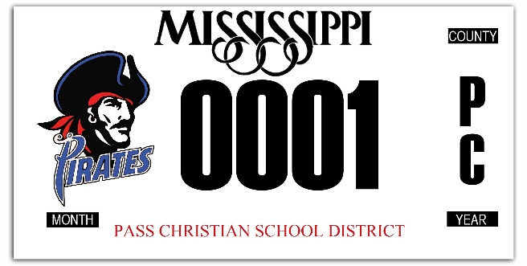
NAME:

ADDRESS:

PHONE NUMBER:

E-MAIL ADDRESS:

COUNTY OF RESIDENCE:
ACTUAL DESIGN MAY DIFFER SLIGHTLY

CURRENT LICENSE PLATE NUMBER:

SPECIALTY LICENSE PLATE FEE: $31.00 (CHECK OR MONEY ORDERS MADE PAYABLE TO PASS CHRISTIAN SCHOOL DISTRICT OR CASH )

Deadline for submission of application and fee is September 15, 2014.
License Plates should be ready for distribution beginning January 2015.

Submit Application and fee to Central Services Office or any school OR you may mail to:
Office of the Superintendent
Pass Christian Public School District
6457 Kiln-DeLisle Road
Pass Christian, MS 39571

DATE: SIGNATURE:

PLEASE NOTE:

Three hundred (300) specialty license plates must be presold before the Mississippi State Tax Commission will begin production on a particular distinctive license plate included in Senate Bill 2472. When the Tax Commission receives the 300 applications with the appropriate fees and a design provided by the organization and approved by the Tax Commission, the specialty license plate can be put into production.

The applicant will be notified by the organization responsible for this particular license plate when his license plate can be picked up at the Office of the Tax Collector in his county of residence. The Tax Collector will have a list provided by the Tax Commission of people who have already paid their fees and are entitled to one of the first 300 specialty license plates.

The applicant should pick up his specialty license plate as soon as he is notified that the license plate is available at the Tax Collector’s Office. There shall be sixty (60) days allowed from the time the taxpayer is notified by the organization for the taxpayer to pick up the license plate. If the applicant chooses to wait beyond the 60 days to pick up his license plate, the specialty license plate fee shall be paid again at the time the specialty license plate is picked up to be registered to the applicant’s vehicle.

Frequently Asked Questions

After I have pre-paid for a special tag and I trade vehicles will I be able to put that tag on my new vehicle?
Please inform the taxpayer that when they go into the county office and give their name they will be allowed to put that license plate on any vehicle of their choice.

How soon after the license plates are available will I have to wait before I must go into the county office and pick up the license plate?
The taxpayer will have up to sixty (60) days after we have informed the organization to advise taxpayers that the license plates are in the county office. If the taxpayer chooses to wait beyond the sixty days they will be required to pay the special fees over again.

Will the taxpayer be required to turn in the license plate which is currently on their vehicle in order to pick up the new license plate?
Yes the tax payer will be required to bring in the old license plate in order to receive the new license plate.

What if a taxpayer purchased one of the license plates while living in one county but has since moved to another county how will they be able to receive their license plate in their new county?
The taxpayer will need to do one of two things, they may go into the new county office and have the clerk to call the other county office to have the license plate forwarded to that particular office or they may contact us and we will have the county to forward the tag to the correct county office.

What happens if taxpayers change their mind and are no longer interested in having the specialty license plate?
Since that particular taxpayer may have been one of the three hundred persons on the list of pre-sold tags it shall be the responsibility of the organization to work out something with the taxpayer in order for your list not to drop below 300 which would make the organization in non-compliance.

How much money does the organization receive from the sale of these tags?
The amount the organization receives is by state statues; currently if your tags are $31.00 the organization will receive $24.00 per tag.

How will the money be used by Pass Christian School District from the sale of these tags?
$12.00 per tag will be allocated to athletics, and $12.00 per tag will be allocated to the band program.

Will I be able to keep the specialty license tag if I decide I would like to have another specialty tag registered to my vehicle?
State statue states if the taxpayer does not wish to have that tag registered to a vehicle it must be turned into the county tax collector’s office.

Can an individual have more than one specialty license plate?
If there is no stipulation in the statue on the number of license plates to be issued per person, then a person can have as many as they want.

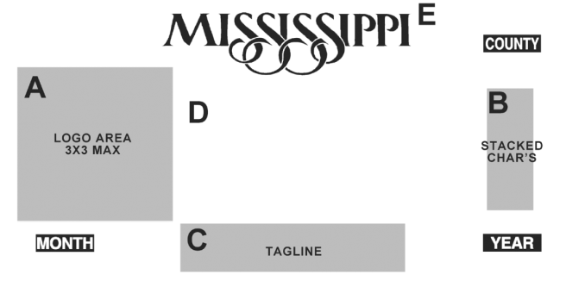

Harrison

Pass Christian School District
0001
P
C
2015
SEPT

