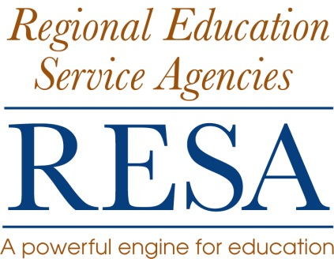
Position Title: 21st Century Community Center Afterschool Programs Director
Location: RESA 4
Salary: RESA 4 Salary Schedule
Contract: All RESA 4 employment agreements are for one year or less. RESA does not issue continuing employment agreements. The agreement for this position is 240 day employment term for FY 2016. The execution of this agreement is contingent upon funding. All RESA 4 personnel are will and pleasure employees of the West Virginia Board of Education.
Job Description:
The employee will:
- coordinate RESA education activities, programs and services, and
- work collaboratively to address the needs of schools and school systems.

Position Qualifications:
- Teaching Certification in Education
- Masters Degree in Education
- Administrative certification and experience (preferred)
- Minimum of five years of teaching experience (preferred)
- Demonstrated experience and knowledge of education programs and initiatives and integration of them with other state, local and federal initiatives
- Knowledge of local, state, and federal education policy and law
- Strong oral and written communication skills
- Ability to schedule, organize, and perform multiple assignments
- Knowledge and expertise in highly effective research-based instructional practices
- Demonstrated knowledge and experience in
  - integrating positive behavior support programs
  - supporting effective school leadership research and practice
  - integrating technology into classroom instruction
  - developing and delivering professional development
  - supporting and facilitating professional learning communities,
  - managing State and Federal program budgets and
  - writing, implementing, and managing grants.

Position Responsibilities:
- Maintain professional work habits
- Administer all RESA 4 21st CCLC programs
- Develop and Write 21st CCLC grants (renewals and new grants) to meet the needs of RESA 4 counties
- Work closely with county school board administrators and individual school administrators in designing and implementing 21st CCLC afterschool programs
- Work closely with county school board administrators and individual school administrators in employing personnel for 21st CCLC afterschool programs
- Monitor finances for all 21st CCLC grants
- Do all required evaluations of 21st CCLC programs (State and Federal)
- Provide appropriate training for 21st CCLC personnel (RESA 4 and Local sites)
- Monitor 21st CCLC program sites for grant compliance
- Provide feedback regarding program progress and compliance to the Regional Council
- Perform other duties as assigned by the Executive Director

Reports To: RESA 4 Director

Application: Send a letter of application, resume, and the names of three
references with phone numbers and e-mail addresses to:

David A. Warvel, Executive Director
RESA 4
404 Old Main Drive
Summersville, WV 26651

Application Deadline: Monday, August 17, 2015

Equal Employment Opportunity: “Equal employment opportunity will be granted to all persons regardless of age, race, creed, national origin, or handicap and no discrimination based upon such factors will be made in salary, promotion, demotion, transfer or termination of any employee.”

