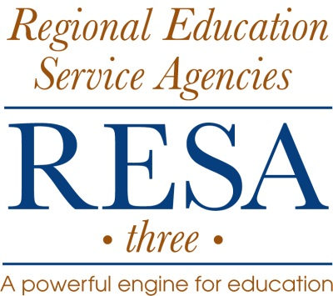

RESA 3

Notice of Position Vacancy

POSITION: Clay County/RESA 3 Adult Basic Education
Part-time hourly Adult Education/SPOKES Instructor

REPORTS TO: RESA 3 Adult Education Senior Director

Expectations:
- Work effectively as a member of an educational team.
- Demonstrate self-control and exhibit an attitude of mutual respect with colleagues and program participants.
- Exhibit ethical behavior and demonstrate good work habits, including punctuality and attendance.
- Demonstrate enthusiasm and create a positive learning environment.
- Demonstrate a willingness to work collaboratively with personnel from other agencies.
- Maintain confidentiality of student information as outlined in section four of the WVAE Instructor Handbook.
- Participate in at least the minimum required Core and Elective professional development sessions per year depending on the number of hours per week of employment. Requirements are adjusted annually according to the WVDE AE Instructor Handbook.
- Maintain applicable teacher licensing as per the WVDE Department of Teacher Certification guidelines, policies and requirements.

Duties and Responsibilities:
- Instruct students in basic skills, high school equivalency, life-coping skills, workforce preparation, college-placement, and computer skills.
- Develop an individual program of study for each student based upon the student’s goals and skill levels.
- Administer/interpret appropriate assessment instruments when necessary.
- Conduct confidential student interviews.
- Utilize a variety of instructional methods and materials that meet individual student needs.
- Apply accommodations for students with special learning needs and make referrals for diagnosis and special support service when appropriate.
- Prepare and submit applicable data relating to student enrollment, progress, and completion (or termination).
- Establish and maintain linkages with community agencies/businesses, career and technical centers, and college programs.
- Establish and maintain open and effective communications with local DHHR staff.
- Develop and deliver integrated SPOKES activities in group settings.
- Develop and deliver academic and special topic small and large group activities.
- Recruit, coordinate, plan extracurricular and supplemental activities including, but not limited to, field trips, guest speakers, special workshops, etc.

Qualifications:
- Professional teaching certificate (preferred) or eligible for an adult license for Adult Basic Education (four year college degree – minimum of 2.5 GPA in original course work; a minimum of 3.0 in course work used in maintenance of certificate or adult license).
- Prior experience in teaching adults preferred.
- Knowledge of the characteristics of adult learners preferred.
- Computer instructional skills required.
- Effective oral/written communication skills required.
- Experience with software management systems preferred.
- Ability to provide basic academic skills, job-readiness, and life-coping skills to adult learners required.
- Ability to attend teacher training prior to the first class meeting required.
- Ability to work collaboratively with other agencies and organizations.
- Familiarity with SPOKES or other workforce or career readiness curriculum preferred.

Evaluation: According to RESA 3 Policy and evaluation procedures.
Term of Employment: All RESA 3 employees are will and pleasure employees of the RESA and the WV State Board of Education. This position is a part-time hourly position. Continuation of the position is dependent upon funding.

SALARY RANGE: $19.00 per hour

DEADLINE FOR RECEIPT OF RESUMES: By 4:00 p.m., Friday, July 8, 2016

Send or e-mail a Cover Letter, RESA Application, Resume, Transcripts and References:
Marie H. Bias-Jones
RESA 3 Adult Education Regional Coordinator
501 22nd Street, Dunbar, WV 25064
Or submit attachments in Word or PDF by e-mail to:
mbjones@k12.wv.us

An application for employment may be obtained by calling the RESA 3 Office of Human Resources at (304) 766-7655 ext. 125 or may be downloaded from the RESA 3 Home Page under Employment Opportunities at: http://resa3.k12.wv.us/Employment/New%20Employee%20Application.pdf
RESA 3 does not discriminate in employment opportunities, employment practices, or participation in any of its services and/or programs on the basis of race, color, religion, sex, national origin, age, disability, or any other characteristic protected by law.

