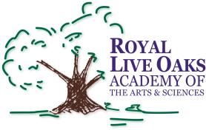 1398 Church Road, Hardeeville, SC 29927 • 843-784-2630 • www.rloacs.org

AGENDA

The Royal Live Oaks Academy of Arts & Sciences Charter School Board Meeting
October 21, 2014 6:30pm
Royal Live Oaks Classroom 6A

- Old business:

  - Approval of Minutes of September 16, 2014 meeting - Secretary

- New business:

  - RLOA Mission Statement - Chair

  - Finance Report - Bill Moser, Kelly-Moser Consulting

  - Audit Review – Ed Royall, Elliott Davis

  - Update on Approvals of Renovations and New Modulars – Executive Director

  - Update on New Campus, Finance - Facilities Development

  - School Updates – Executive Director

  - Other

- Public Comment

