1. LOG IN to eSchoolPlus + ---------------https://eschoolplus24.k12.ar.us/TAC24
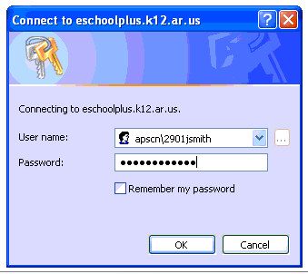

User Name: apscn\6091(first initial last name) Ex: apscn\6091jsmith
Password: *************
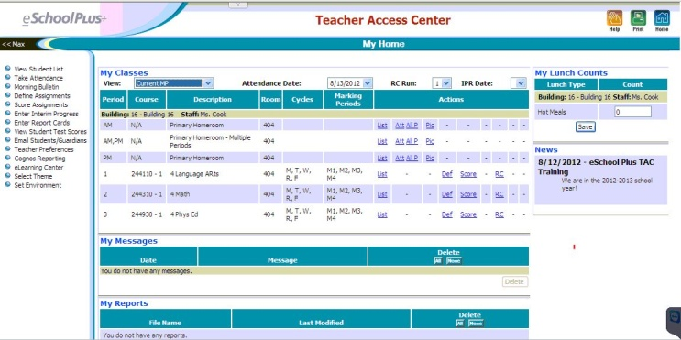

2. Teacher Access Center – My Home Page opens
Homeroom (if assigned) is listed first
Class List (My Classes)

3. View Options

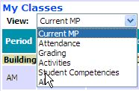
Click drop down

arrow to change.
Use to clean-up
your main page

Activities & Student Competencies not used in Ark.

Attendance –

Click List to view students enrolled in this course.
Att – click to enter absence
All P – click if all students are present
Pic – (Not used in Arkansas)
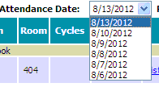
Today’s date is always listed first.
To change date, click drop-down arrow.
Teachers can only go back 10 days
After 10 days, the office must enter
This option should only be used for
attendance when you have a substitute.
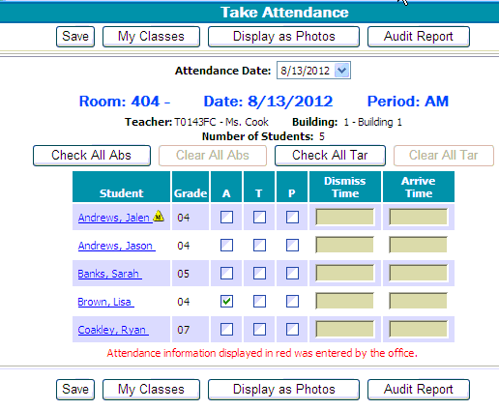

Click box next to student name to mark
Absent (A) or Tardy (T)

To correct a mistake mark (P) Present
*Student marked absent, but was in fact present.
i.e. detained in office – school business, etc.

Click Save
Click My Classes to return to home page
Gradebook
Define Categories - Click Def
This step only required once per year

If this page does not appear –
click Categories Tab
*If no categories have been selected,
this page should come up by default.
MOST IMPORTANT!
!!CLICK THIS BOX!!
Calculate Average Using
Total Points

If this box is not checked, your grades will NOT average!

Select all possible assignment types you plan to use during the year.
You can always add categories later by clicking the categories tab again if needed.
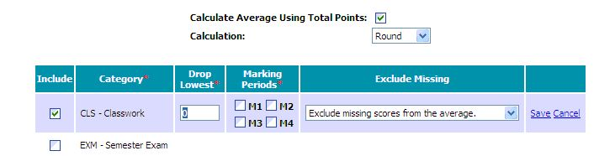

Click Save

LEAVE BLANK!! It will default to all year.
For multiple classes use the COPY feature to duplicate your choices

OR Repeat the above steps for each class.
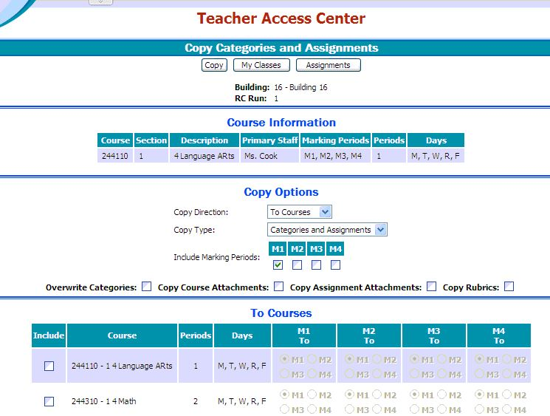
This page will open.

1. Click all Marking Periods
2. Click Overwrite Categories
3. Check under Include for each class
to copy the categories to.
4. Click Include ALL button
5. Click Copy
6. You will return to Define Categories Page
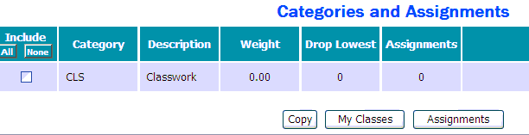CHECK & MAKE SURE THE BOX IS CHECKED!!
My Home – Click Def for each class
Go to Categories for each
CHECK & MAKE SURE THE BOX IS CHECKED!!

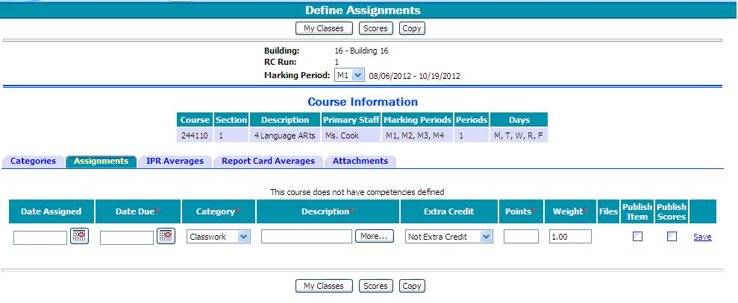 Define Assignments - Click Def

1. Click Assignments Tab

2. Click Calendar icon
to select date.

*For HAC you can enter Date Assigned & enter Date Due either now or later. Not Required.
Parents will still see assignment online either way. Good way to show parents how long
students have to complete the work. DATE DUE IS REQUIRED.

3. Click drop down arrow and choose assignment type under Category.
4. Enter description (i.e. Page #s, Titles, etc. – Chapter 1 Definitions, p.7)
*For HAC – Enter enough information so that you, parents, & students can recognize assignment.
If more room is needed, click More… and a larger box will open.
Use to enter specific requirements to be viewed in HAC

5. If Extra Credit Assignment – Choose option from drop down arrow. Otherwise hit TAB to skip
6. Points = Maximum points possible
7. DO NOT Change weight. (Hit Tab to skip) It is recommended to weight assignments, increase
total points possible. (Ex.- 10 points Homework, 50 points for classwork, 100 points for test)
8. Files (Not used in Arkansas at this time)
9. Click Publish Item & Publish Scores to send to HAC.
10. Click Save
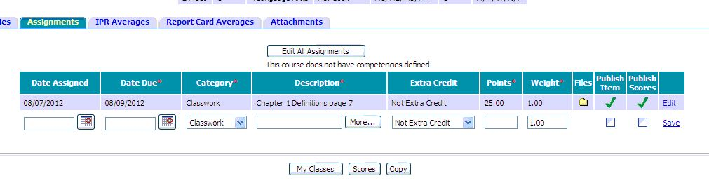
(Not available in Arkansas)

Continue to add assignments or Click Scores to enter grades.

For multiple classes use the COPY feature to duplicate your choices
This works the same as for copying Categories on the previous page.
Good option if you teach the same subject to several classes and they have the same assignments.
You can choose to copy all or select specific assignments to copy.

The Edit All Assignments button will open all assignments to adjust dates or other information for different classes after copying. Be sure to Click Save after making changes.

**NOTE: Assignments may be deleted if NO grades have been entered.
Be sure to delete scores or the delete option will not be available.
(Ex. Oops! I’m in the wrong class! or That assignment was a bad idea---just didn’t work)

Enter Grades - Click Score

TIP: Make sure your gradebook has students in the same order as TAC.

Click arrow to hide column
Indicates student has a
Medical Alert or SPED

Enter student score
Hit Enter to go down the list
Saves automatically.

(Option Not available)
OPTIONS:

Click Student’s Name to show individual information – address, phone, parents, schedule, and attendance.
Hover mouse over name to see date student enrolled if a new student.

Click Notes to enter comments about the student. You can choose to publish in HAC or keep for your
own information. Multiple notes may be added for each student and may be edited as needed. Only
one note allowed per date.
Example: Late work, Extended Time Allowed, etc.
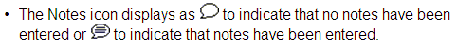

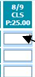DEFAULT GRADE
Top of Score Page
Click column for the scores to be entered first.
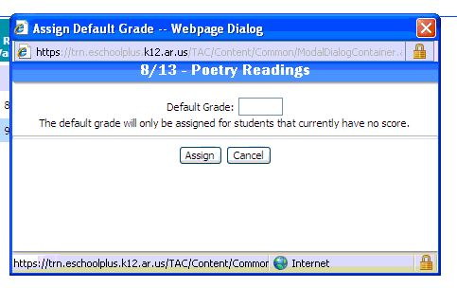Click Button
Enter Score for all students.
Click Assign.

*Good for Participation!

PROGRESS REPORTS REPORT CARDS
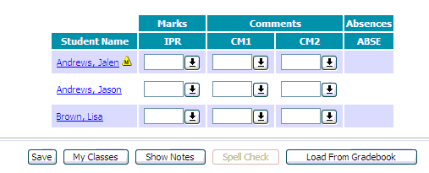Click IPR Click RC
Click Load from Gradebook Click Load from
Click CM1/CM2 to add Comments Gradebook
Click Save Click CM1/CM2 to add
Comments
Click Save
Look for the Big Green Check on the Home Page

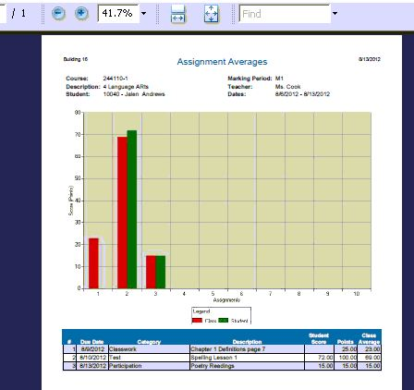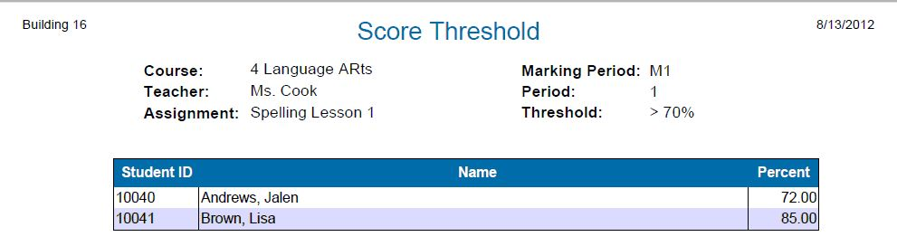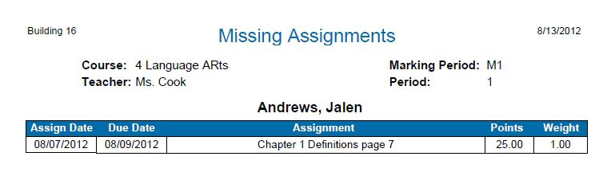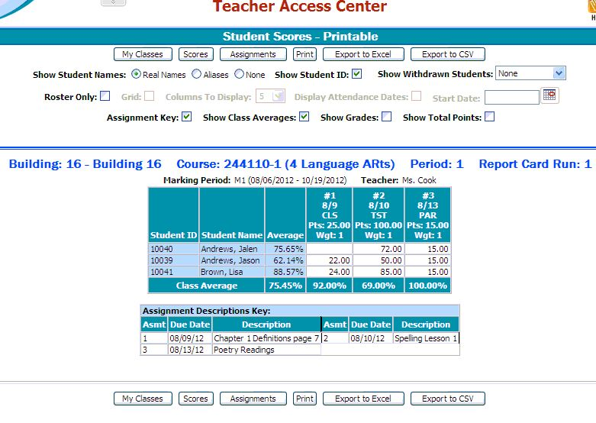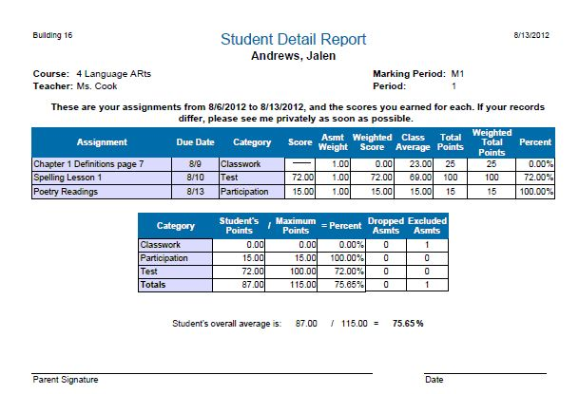SCORE MENU OPTIONS
Compares Student to Class Average
See Student Average
Enter a Comment about a Score
Allows Teacher to Assign Alias to Students
Report of all
Blank Grades
Copy of Score Entry page
(Gradebook)
Report of a Single Student’s Scores
(Progress Report
Return
to Def
Page
Return
to Home
Page

Lists all students above or below a given score

TAC UPGRADE – ADDED FEATURES

1. Log In - https://eschoolplus24.k12.ar.us/TAC24
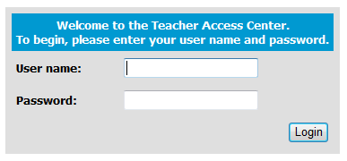
You no longer have to type apscn\ to access TAC.
You can just enter 6091 and your user name.
It will work either way.

The first time you log in you may have to select OUR School District from the drop-down box.
After the first time, it should default to our school.
Please select a database:
Ar School for the Blind School District

2. View setting - In My Classes, when you select another view
(such as Grading or Current MP), your gradebook will automatically open in this view until you change it.

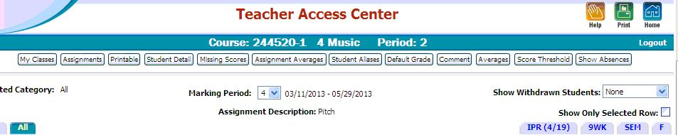3. Show Absences - In Scores. There is a new button at the top right hand side of the screen to Show Absences.

When clicked: The student's score box will be outlined in red to show the student was absent on that day. (See picture below)
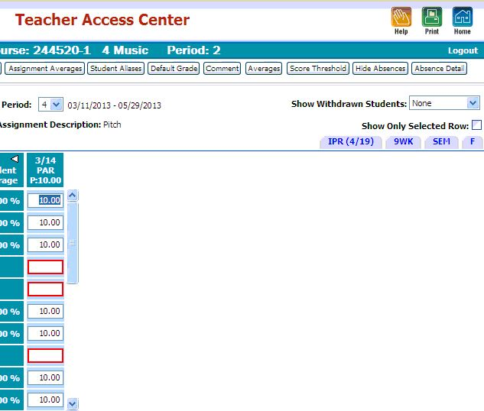
Two new buttons appear (Hide Absences & Absence Detail).

Hide Absence turns this feature off.
Absence Detail - Click the student box for the grade then click this button. A detail box will pop up showing if the absence was entered as excused or unexcused.

4. My Messages - Home page - A new box shows messages at the bottom of the screen. If a student
is added, dropped, or has other alerts set by the office, you may get a notification here.

5. Logout - A new Logout button has been added on all pages. Click Logout when leaving TAC
without closing your browser. (Added security)

JUST THE BASICS – Cheat Sheet.

1. Log in – https://eschoolplus24.k12.ar.us/eschoolplus24
Must be on school server or VPN to APSCN

2. User Name: LEA#(first initial last name) Ex. 6091jsmith
Password: ************
- To Change Password go to apscn.org>Security> Security Resources>Self Management State Active Directory of Account Passwords (3rd choice under “Active Directory”)

3. Def – Categories - Check the Box!!!
Choose assignment types – Leave the marking period boxes BLANK!

4. Def – Assignments - Enter information *Indicates a required field

5. Score – Enter Grades Use Default Button to give all blank boxes the same grade

6. IPR - Load Grades for Progress Reports

7. RC – Load Grades for Report Cards

8. Att – Attendance All P – All Present
Elementary only – AM Homeroom & PM Homeroom = ½ day absence
AM/PM Homeroom = All Day (Most Used) – in the middle
7. List – Class List Click Print for quick roster (good for subs)

Troubleshooting:

- Use the Help Button - Brings up help for the screen you are on
- Grades do not average – Click the box in Categories (Def)
Make sure that Marking Period boxes show default!
If not, click Edit, uncheck the boxes, & Save
- Can’t Log In – Try changing password. Use Internet Explorer 8 or 9. (NOT 10!)
- Change Password –https://adedata.arkansas.gov/security/
Single-Sign On (SSO)>ADE Single Sign On (Sign in)
- Any issues – Contact _Cindy Wilkinson 296-1815 or cindy.wilkinson@asb.k12.ar.us

